 | PERSONALIZED DIET-WORKOUT PAIR RECOMMENDATION AND ADAPTIVE FITNESS TRAJECTORY PREDICTION USING USER-CENTRIC DATA | 

A PROJECT REPORT
Submitted by

NAKUL DEV M V | 720922104304
BAISIL JOSE | 720922104017
ARAVIND MOHAN | 720922104013
APARNA P | 720922104012

in partial fulfillment of the requirements for the award degree of
BACHELOR OF ENGINEERING
in
cOMPUTER SCIENCE AND ENGINEERING

JCT COLLEGE OF ENGINEERING AND TECHNOLOGY
(AUTONOMOUS)
COIMBATORE - 641105
April 2026
JCT COLLEGE OF ENGINEERING AND TECHNOLOGY
(AUTONOMOUS)
COIMBATORE - 641105

Bonafide CERTIFICATE
Dr. S. Sakthi Vinayagam  SUPERVISOR  Department of Computer Science and Engineering  JCT College of Engineering and Technology  Pichanur, Coimbatore - 641105 | Dr. P. D. R. Vijayakumar  HEAD OF THE DEPARTMENT  Department of Computer Science and Engineering  JCT College of Engineering and Technology  Pichanur, Coimbatore - 641105
Certified that this project report “PERSONALIZED DIET-WORKOUT PAIR RECOMMENDATION AND ADAPTIVE FITNESS TRAJECTORY PREDICTION USING USER-CENTRIC DATA” is the bonafide work of students Nakul Dev M V, Baisil Jose, Aravind Mohan V, Aparna P who carried out the project work under my supervision.
Submitted for the Viva Voce examination held on ……………………

internal eXAMINER EXTERNAL EXAMNIER
JCT COLLEGE OF ENGINEERING AND TECHNOLOGY
(AUTONOMOUS)
COIMBATORE - 641105

Bonafide CERTIFICATE
We jointly declare that the project report on “PERSONALIZED DIET-WORKOUT PAIR RECOMMENDATION AND ADAPTIVE FITNESS TRAJECTORY PREDICTION USING USER-CENTRIC DATA” is the result of original work done by us and best of our knowledge, similar work has not been submitted to “ANNA UNIVERSITY CHENNAI” for the requirement of Degree of Bachelor of Engineering. This project report is submitted on the partial fulfilment of the requirement of the award of Degree of BACHELOR OF ENGINEERING in COMPUTER SCIENCE AND ENGINEERING.
Signature

Place: Coimbatore
Date:
ABSTRACT
This project presents a Personalized Diet-Workout Pair Recommendation System to support users in managing health and fitness goals through customized diet guidance, workout planning, interaction. Fitness applications often give generalized suggestions that do not reflect a user’s body profile, goal, adherence level, calorie intake, calorie burn, and lifestyle patterns. The system addresses this by combining profile-driven personalization, predictive analytics, and recommendation support within one platform. It is implemented using a React frontend, a Node.js and TypeScript backend, and a Python analytics service connected through a PostgreSQL database. The Node backend manages authentication, profile completion, plan selection, check-ins, and progress APIs, while the Python backend handles calorie estimation, weight prediction, summary generation, and AI retrieval workflows. The prediction component uses BMR, TDEE, and energy-balance projection with machine learning support to generate progress curves. The AI coach module responds to user queries using profile information, recent activity logs, and knowledge-based content through retrieval. The project includes dataset preparation, feature engineering support, API contracts, and testing modules to improve reproducibility and quality. Overall, the system provides an integrated, scalable, and extensible framework for personalized digital health recommendation and monitoring.

ACKNOWLEDGEMENT

We express our sincere gratitude to the management of JCT College of Engineering and Technology for providing us with the opportunity and facilities to successfully complete our undergraduate project.
We are immensely thankful to our esteemed Founder, Thiru. S. A. Subramanian, for his visionary leadership and continuous support towards academic excellence.
We extend our heartfelt thanks to our Chairman, Thiru. R. Arulselvan, Vice Chairman, Thiru. R. Gautaman, and Secretary, Thiru. R. Duga Shankar, for their constant encouragement and for creating a conducive environment for learning and research.
We express our deep sense of gratitude to our respected Principal, Dr. S. Manoharan, for his valuable guidance and support throughout the course of our project work.
We are highly thankful to our Head of the Department, Dr. P. D. R. Vijayakumar, for his continuous support, motivation, and guidance which helped us in completing our project successfully.
We are highly indebted to our Project Coordinator, Dr. T. Rajendran, for his valuable suggestions, motivation, and continuous encouragement which greatly contributed to the successful completion of this project.
We would like to express our sincere thanks to our Project Supervisor, Dr. S. Sakthi Vinayagam, for his expert guidance, constructive suggestions, and constant support at every stage of the project.
We also extend our gratitude to all the faculty members of CSE department and various departments and the technical staff members for their support and cooperation.
Finally, we express our heartfelt thanks to our parents and friends for their encouragement, moral support, and inspiration throughout the completion of this project.

APARNA P (720922104012)
ARAVIND MOHAN V (720922104013)
BAISIL JOSE (720922104017)
NAKUL DEV M V (720922104304)

TABLE OF CONTENTS
CHAPTER NO. | TITLE | PAGE NO.
 | ABSTRACT | iii
 | ACKNOWLEDGEMENT | v
 | LIST OF TABLES | xii
 | LIST OF FIGURES | xvi
 | LIST OF SYMBOLS AND ABBREVIATIONS | xxiii
1 | INTRODUCTION | 12
 | 1.1 Background of Personalized Health Recommendation Systems | 12
 | 1.2 Problem Statement | 13
 | 1.3 Objectives of the Project | 14
 | 1.4 Scope of the Work | 14
 | 1.5 Motivation and Need for the System | 15
 | CHAPTER 2: LITERATURE SURVEY | 17
 | 2.1 Existing Diet Recommendation Systems | 17
 | 2.2 Existing Workout Recommendation Systems | 18
 | 2.3 Progress Prediction in Health Applications | 19
 | 2.4 AI-Based Health Assistance and Retrieval Systems | 20
 | 2.5 Research Gap and Project Positioning | 21
3 | PROBLEM DEFINITION AND REQUIREMENT ANALYSIS | 23
 | 3.1 Problem Definition | 23
 | 3.2 Functional Requirements | 24
 | 3.3 Non-Functional Requirements | 25
 | 3.4 Software and Hardware Requirements | 26
 | 3.5 Feasibility Analysis | 27
4 | SYSTEM ARCHITECTURE AND DESIGN | 30
 | 4.1 Overall Architecture | 30
 | 4.2 Frontend Design | 31
 | 4.3 Backend Node Service Design | 34
 | 4.4 Backend Python Analytics Design | 36
 | 4.5 Module Interaction Overview | 37
5 | DATABASE DESIGN AND DATA FLOW | 38
 | 5.1 Database Overview | 38
 | 5.2 Core Tables and Relationships | 38
 | 5.3 Operational Data Flow | 40
 | 5.4 Prediction and Snapshot Data Flow | 41
 | 5.5 AI Retrieval Data Flow | 42
6 | DATASET PREPARATION AND FEATURE ENGINEERING | 43
 | 6.1 Plan Dataset Preparation | 43
 | 6.2 Reference Data Sources | 45
 | 6.3 Feature Engineering Workflow | 45
 | 6.4 Data Validation and Consistency Checks | 46
7 | PREDICTION ENGINE AND RECOMMENDATION METHODOLOGY | 48
 | 7.1 Calorie Intake and Burn Estimation | 48
 | 7.2 BMR and TDEE Computation | 49
 | 7.3 Weight Projection Logic | 50
 | 7.4 Residual Machine Learning Models | 51
 | 7.5 Deviation Score and Risk Flags | 53
8 | AI COACH AND PERSONALIZATION LOGIC | 54
 | 8.1 AI Coach Module Overview | 54
 | 8.2 Intent Classification | 55
 | 8.3 Multi-Stream Retrieval Pipeline | 56
 | 8.4 Context Synthesis | 57
 | 8.5 Grounded Response Generation | 58
9 | IMPLEMENTATION DETAILS AND API WORKFLOWS | 60
 | 9.1 Authentication and Profile Flow | 60
 | 9.2 Plan Selection and Daily Check-In Flow | 62
 | 9.3 Progress Chart and Summary Flow | 63
 | 9.4 Alternative Plan Workflow | 64
 | 9.5 AI Question-Answer Workflow | 65
10 | TESTING, EVALUATION, AND DISCUSSION | 67
 | 10.1 Unit Testing and Integration Testing | 67
 | 10.2 Prediction Validation | 68
 | 10.3 AI Retrieval and Response Testing | 69
 | 10.4 Experimental Observations | 70
 | 10.5 Discussion of Results | 70
11 | CONCLUSION AND FUTURE ENHANCEMENTS | 72
 | 11.1 Conclusion | 72
 | 11.2 Limitations | 73
 | 11.3 Future Scope | 74
 | APPENDICES | 75
 | A.1 Sample API Payloads | 75
 | REFERENCES | 76

LIST OF TABLES

TABLE NO. | TITLE | PAGE NO.
2.1 | General comparison between diet and workout recommendation systems | 19
4.1 | Major architectural layers and their responsibilities | 31
4.2 | Main responsibilities of the Node backend service | 35
4.3 | Main responsibilities of the Python analytics service | 36
5.2 | Core tables used in the application database | 40
5.4 | Prediction-related data artifacts stored by the system | 42
6.1 | Summary of synthetic plan datasets used in the project | 44
7.1 | Inputs used for calorie-related estimation in the project | 49
7.3 | Prediction outputs supported by the hybrid pipeline | 52
7.4 | Examples of interpretation signals generated by the prediction layer | 53
8.1 | Intent types used in the AI coach module | 56
9.2 | Important plan and daily check-in endpoints | 63
10.2 | Key prediction validation goals in the project | 68
10.3 | Representative AI retrieval and assistant testing concerns | 69
A.1 | Representative Profile Update Payload | 75
A.2 | Representative Daily Check-in Payload | 75

LIST OF FIGURES
FIGURE NO. | TITLE | PAGE NO.
4.1 | Overall System Architecture of the Proposed System | 31
4.2 | Dashboard Interface Showing Aggregated Progress and Plan Information | 33
4.3 | Tracker Interface for Check-in History and Progress Interpretation | 34
5.1 | Database Relationship Overview of the Implemented System | 39
6.1 | Feature Engineering Workflow Used for the Prediction Pipeline | 44
7.1 | Hybrid Prediction Pipeline from Metabolic Baseline to User-Adjusted Projection | 52
8.1 | AI Coach Interface for Personalized Question-Answer Support | 55
8.2 | Multi-Stream Retrieval Workflow Used by the AI Coach | 57
9.1 | User Flow from Registration and Login to Dashboard Access | 61
9.2 | Plan Selection and Daily Check-in Flow in the Implemented System | 63
9.3 | RAG Retrieval and Streaming Pipeline for AI Question-Answer Flow | 66
9.4 | Login and Registration Interface of the System | 61
9.5 | Profile Setup Interface for User Personalization | 62
10.1 | Evaluation Flow Followed in Testing and Discussion | 67

LIST OF SYMBOLS AND ABBREVIATIONS

SYMBOL / ABBREVIATION | EXPANSION
AI | Artificial Intelligence
API | Application Programming Interface
BMR | Basal Metabolic Rate
TDEE | Total Daily Energy Expenditure
ML | Machine Learning
RAG | Retrieval-Augmented Generation
JSON | JavaScript Object Notation
SQL | Structured Query Language
DB | Database
UI | User Interface
UX | User Experience
kcal | Kilocalories
BMR (Male) | 10W + 6.25H − 5A + 5
BMR (Female) | 10W + 6.25H − 5A − 161
Node.js | JavaScript Runtime for Backend
React | Frontend JavaScript Library
FastAPI | Python Framework for APIs
PostgreSQL | Relational Database System
Prisma | ORM for Node.js
SQLAlchemy | ORM for Python
ANALYTIC | User-data driven AI query type
KNOWLEDGE | General information query type
HYBRID | Mixed context AI query type

CHAPTER 1

INTRODUCTION

Background of Personalized Health Recommendation Systems
Health and fitness have become an important part of everyday life, especially for students, working professionals, and people trying to manage weight-related issues. Many individuals want to follow a better diet, exercise regularly, and keep track of their progress, but in practice this is not easy. People often depend on random internet advice, generic calorie charts, or workout suggestions taken from social media. These sources may be useful at a basic level, but they rarely consider personal differences such as age, body measurements, food preference, activity level, consistency, and long-term goal.
In recent years, digital health platforms have tried to solve this problem by offering calorie trackers, exercise libraries, and progress dashboards. However, many of these systems still work in a broad and generalized way. A user may receive the same kind of recommendation as thousands of others even though their health condition, daily routine, and goal may be completely different. For example, a person trying to lose weight with a vegetarian diet and low daily activity should not be guided in the same way as a person trying to gain muscle with regular gym training.
This is where personalized recommendation systems become useful. A personalized health system does more than simply store food logs or workout entries. It studies the user’s profile, records daily behavior, estimates calorie intake and calorie burn, and then gives guidance that is more suited to that person. If the system can also track progress and explain why the user is moving closer to or farther from the goal, it becomes much more practical and meaningful.
The project developed in this work focuses exactly on that need. It brings together diet guidance, workout recommendation, daily logging, prediction of progress, and an AI-based support module in one platform. Instead of treating these features as separate utilities, the system connects them into one workflow so that user data collected in one part of the application can improve the quality of recommendations in another.

Problem Statement

Many available fitness applications provide food logging, exercise suggestions, or progress charts, but they often fail to combine these features in a truly personalized way. In most cases, the advice given to users is static, limited, or not properly connected to their real behavior over time. This creates a gap between what the application recommends and what the user actually needs.
The main problem addressed in this project can be stated as follows:

How can a digital system provide personalized diet and workout pair recommendations, track daily health-related activities, predict progress realistically, and answer user queries intelligently using both profile data and logged history?
Solving this problem requires more than building a normal CRUD-based application. The system must handle user authentication, profile capture, plan selection, daily check- ins, calorie estimation, progress tracking, and AI-supported recommendations in a coordinated way. It should also be able to process both structured data, such as weight, steps, sleep, and calories, and unstructured knowledge content used for answering user questions.
The problem becomes even more important when users expect the system to be understandable and useful in real life. If the recommendation does not match the user’s goal or if the progress graph does not reflect actual adherence, the system loses value. Therefore, the project is designed not only to store user data, but to convert that data into meaningful insight and guidance.

Objectives of the Project

The main objectives of the project are listed below:

    - To design and develop a personalized diet and workout recommendation platform for health and fitness management.
    - To create a user-centered system that supports authentication, profile setup, plan selection, and daily activity logging.
    - To calculate calorie intake, calorie burn, and related health indicators using structured user inputs.
    - To generate progress predictions using a combination of formula-based methods and machine learning support.
    - To provide meaningful progress summaries, deviation indicators, and recommendation outputs based on user history.
    - To integrate an AI coach module that can answer user questions using both knowledge documents and user-specific activity data.
    - To build the system using a modular full-stack architecture that is suitable for further extension and academic evaluation.

These objectives were chosen so that the final system would not remain a simple tracking application. The intention was to build a complete workflow where data collection, analysis, recommendation, and user assistance are all connected.

Scope of the Work

The scope of this project is limited to the design and development of a software-based personalized health recommendation platform. The work mainly focuses on application logic, data handling, prediction workflows, and AI-assisted interaction. The frontend is responsible for user interaction, the Node backend handles operational APIs and user- facing workflows, and the Python backend handles analytics, prediction, and retrieval tasks.
The project includes the following major features within its scope:
    - user registration, login, and profile management,
    - plan selection and daily diet-workout check-ins,
    - calorie intake and calorie burn estimation,
    - progress chart generation and summary analysis,
    - alternative plan and recommendation support,
    - AI coach support using retrieval over user data and knowledge content,
    - dataset preparation, model support, and testing artifacts.

At the same time, some areas are outside the current scope of the project. The system does not aim to provide clinical medical diagnosis, wearable-device-level live monitoring, or certified nutritional consultation. It also does not attempt to replace doctors, trainers, or dietitians. Instead, it works as a digital assistance platform that helps users monitor their routine and receive better structured guidance.

Motivation and Need for the System

The motivation for this project comes from a simple real-world observation: many people want to improve their health, but they struggle to stay consistent because they do not receive guidance that feels personal, clear, and measurable. A person may know that eating well and exercising regularly are important, but may still not know what kind of diet suits their goal, how much workout is enough, or whether the effort they are putting in is producing real change.
Most users also find it difficult to connect daily actions with long-term outcomes. For example, if someone skips workouts frequently, eats above the target calorie level, or sleeps poorly, the effect may only become visible after several days or weeks. A system that can capture these daily details and explain progress in a clear way becomes valuable. This is especially true when the system can show not only what has happened, but also what is likely to happen if the current pattern continues.
Another major motivation is the growing role of AI in user-facing applications. Users increasingly expect systems to answer questions in natural language, explain their progress, and give suggestions in a more conversational form. However, generic AI answers are not enough for health-related support. The answer becomes useful only when it is grounded in the user’s own profile, past logs, and relevant knowledge content. This project explores that idea through an AI coach that combines retrieval and personalization.
This chapter introduced the purpose and direction of the project. The next chapter reviews the related work and explains how this system fits into the broader area of personalized health recommendation and AI-assisted fitness support.

CHAPTER 2

LITERATURE SURVEY

Existing Diet Recommendation Systems

Diet recommendation systems are one of the earliest and most common forms of digital health applications. Most basic systems focus on calorie tracking, food logging, and meal suggestions. Their main goal is to help users understand what they consume in a day and whether that intake matches a target range. Some applications use fixed calorie tables, while others allow users to select foods from a catalog and automatically estimate nutritional values.
Over time, diet systems became more advanced by including user profile data such as age, gender, weight, height, food preference, and goal type. This made recommendations more relevant than simple one-size-fits-all calorie lists. For example, a user trying to lose weight and a user trying to gain weight should not receive the same meal suggestions even if both consume similar food categories. Systems that consider such differences usually offer better user engagement and better practical value.
Even with these improvements, many diet recommendation platforms still have limitations. A common issue is that the recommendation is generated once during onboarding and then remains mostly static. In real life, food habits change from day to day, and a recommendation that is valid in the first week may not be ideal after several check-ins. Another issue is that many systems focus only on food intake and ignore related factors such as workout completion, sleep, daily steps, or adherence consistency. This reduces the quality of personalization.
For this reason, modern diet recommendation research often moves toward dynamic and user-aware systems. These systems rely not only on profile details but also on recorded behavior over time. That idea directly supports the current project, where diet recommendation is treated as one part of a larger health workflow rather than as an isolated module.

Existing Workout Recommendation Systems

Workout recommendation systems are designed to guide users in choosing exercises, routines, and intensity levels based on their goal and physical condition. In simple systems, users select a predefined goal such as fat loss, weight gain, or general fitness, and the application responds with a static workout plan. These systems are useful for beginners, but they often lack flexibility and cannot explain whether the selected routine is working well for the user over time.
More advanced systems attempt to personalize workout plans using information such as BMI, activity level, prior exercise history, preferred workout type, and target body outcome. Some platforms include progress-based adjustments, where the workout difficulty or frequency changes depending on user adherence. This is important because workout recommendations must remain practical. A plan that looks ideal in theory may fail in practice if it is too hard, too time-consuming, or poorly matched to the user’s actual routine.
Another important trend in workout recommendation research is the combination of exercise planning with measurable activity signals. Steps count, workout completion percentage, and estimated calorie burn are often used to understand how active a user really is. This is more meaningful than relying only on declared fitness goals. When workout systems do not consider actual compliance, the recommendation becomes disconnected from real user behavior.
In the context of this project, workout recommendation is not treated as a separate task from diet recommendation. Both are linked because fitness outcomes depend on the balance between energy intake, energy expenditure, and adherence. This paired view is one of the main reasons the present system goes beyond a simple exercise suggestion application.

System Type | Typical Strength | Common Limitation
Diet Recommendation Systems | Good at calorie tracking and meal suggestion | Often static and less connected to real daily behavior
Workout Recommendation Systems | Helpful for exercise planning and goal-based routines | May ignore diet, adherence variation, and long-term progress
Integrated Health Systems | Better view of overall user lifestyle and outcome trends | More complex to build and maintain due to multi-module interaction
Table 2.1: General comparison between diet and workout recommendation systems in prior approaches.

Progress Prediction in Health Applications

Prediction has become an important area in digital health platforms because users do not just want to record data; they want to know what the data means. A person who logs food, workouts, and body measurements expects the system to show whether the current routine is leading toward the intended outcome. This is where progress prediction systems become useful.
Traditional prediction methods in health applications often rely on rule-based equations. For example, calorie deficit and calorie surplus models are commonly used to estimate expected changes in body weight. Similarly, BMR and TDEE equations are used to understand how much energy a user needs in a day. These methods are interpretable and easy to apply, which makes them widely used in fitness tools and health calculators.
However, purely formula-based prediction can feel too rigid because real human behavior is not perfectly linear. People do not follow their diet exactly every day, workout intensity changes, and sleep or lifestyle factors can influence actual progress. Because of this, more recent systems combine baseline health equations with statistical or machine learning support. This hybrid approach allows applications to keep the explainability of health formulas while improving realism using observed patterns from data.
Another major development is the use of progress summaries rather than raw numbers alone. Instead of only showing a future weight estimate, modern systems also highlight deviation, risk flags, and differences between ideal progress and actual progress. This helps users understand not just the expected result, but also the reason behind success or delay.
The present project follows this direction closely. It uses standard health calculations such as BMR, TDEE, and energy-balance-based projection, but also supports a more realistic prediction pipeline through residual machine learning models and progress interpretation. This combination makes the system more practical than a static target calculator.

AI-Based Health Assistance and Retrieval

Systems

AI-based health assistance has grown rapidly because users increasingly expect applications to respond in conversational language. Instead of searching through menus or interpreting charts on their own, users want to ask questions such as “Why is my weight not changing?”, “What should I improve this week?”, or “Why am I not meeting my target?” This creates a need for systems that can explain health information in a clear and personalized way.
Early AI assistants in fitness platforms were usually generic chatbot layers placed on top of a normal application. They could answer broad health questions, but their responses were not strongly connected to the user’s actual data. As a result, the interaction often felt generic and repetitive. A useful health assistant should do more than repeat textbook advice. It should combine domain knowledge with user-specific evidence.
This requirement has led to the rise of retrieval-based and retrieval-augmented systems. In these systems, the model does not answer only from general language patterns. Instead, it first retrieves relevant information from stored documents, user logs, or profiles, and then generates a grounded response. This is especially important in health and fitness applications, where user trust depends on whether the explanation reflects actual activity history.
Another useful development is multi-stream retrieval. Instead of depending on one source alone, the system collects information from different channels, such as profile data, temporal logs, and knowledge documents. This improves context quality and allows the assistant to respond differently when user data is insufficient. Such a design is
far more suitable for practical digital health guidance than plain text generation without context.
The current project adopts this modern view. Its AI coach is not a standalone generic chatbot. It combines user profile details, recent performance data, and knowledge-based content before generating a response. This makes the system better aligned with current research trends in grounded AI assistance.

Research Gap and Project Positioning

From the literature and current application trends, an important gap becomes clear. Many systems are strong in one area but weak in another. Some applications are good at diet logging but do not include meaningful workout pairing. Some provide workout routines but do not connect them with food habits and progress prediction. Others include AI chat support, but the conversation is not grounded well in user-specific data.
Another gap lies in integration. In practice, users do not experience health management as separate tasks. They eat, exercise, sleep, track progress, and ask questions as part of one ongoing lifestyle. Therefore, a useful system must connect these pieces rather than treating them as isolated modules. That is one of the main reasons the present project is built as an integrated platform with a frontend, an operational backend, an analytics backend, and a retrieval-based AI support layer.

This project positions itself at the intersection of four important areas:
    - personalized diet recommendation,

    - workout recommendation and adherence tracking,

    - progress prediction using health formulas and data-driven support,

    - grounded AI-based user assistance.

Instead of solving only one of these problems, the project combines them into a single workflow. This makes the work relevant not only from an application-development perspective, but also from a systems-design perspective. The literature survey therefore shows that the project is not repeating a common calorie tracker idea. It is attempting to build a more complete, personalized, and explainable digital health assistance system.
This chapter reviewed the major areas related to the project and highlighted the limitations of existing approaches. The next chapter moves from literature context to the actual problem definition and requirement analysis of the proposed system.

CHAPTER 3

PROBLEM DEFINITION AND REQUIREMENT ANALYSIS

Problem Definition

The main idea behind this project is simple: users need a system that does more than just store health data. A useful health application should understand who the user is, what goal the user is trying to achieve, how consistently the user follows the plan, and whether the current routine is producing the expected result. In many existing applications, these parts are available separately, but they are not tightly connected.
In practical terms, the problem can be defined as the challenge of building a digital platform that can collect user health-related inputs, process them meaningfully, and return recommendations that are personal, understandable, and useful over time. The system should not stop with calorie counting or exercise listing. It must also support progress interpretation, alternative suggestion generation, and AI-assisted interaction based on actual user history.
The project therefore addresses the following core problem:

How can a software system combine user profile management, diet and workout recommendation, daily check-in tracking, predictive progress analytics, and AI-based assistance into one reliable and personalized workflow?
This problem has both application-level and engineering-level complexity. From the user side, the system must be easy to use and relevant to everyday health management. From the system side, it must coordinate multiple modules, including frontend interaction, operational APIs, analytics computation, database persistence, and retrieval-based AI support. This chapter explains the requirements identified to solve that problem in a structured way.

Functional Requirements

Functional requirements describe what the system must do. For this project, the requirements are derived from the actual flow followed by the application, starting from user onboarding and extending to prediction and AI-based support.
The system shall satisfy the following major functional requirements:

    - User registration and authentication: The system shall allow users to register, log in, log out, and manage authenticated sessions securely.
    - Profile management: The system shall capture and update user profile information such as age, height, weight, goal type, food preference, and related health details required for personalization.
    - Plan selection: The system shall present available diet-workout plans and allow the user to select an active plan.
    - Daily check-in support: The system shall allow users to submit daily records including weight, food intake, workouts, steps, sleep, and completion status.
    - Calorie estimation: The system shall calculate calorie intake and calorie burn from the submitted daily data.
    - Progress chart generation: The system shall generate ideal and actual progress lines for the user based on recorded and predicted values.
    - Progress summary generation: The system shall provide summaries, deviation indicators, and risk flags to explain user progress.
    - Alternative recommendation support: The system shall generate alternate sug- gestions or plan options when required.
    - AI coach interaction: The system shall allow users to ask questions and receive responses generated using relevant knowledge content and user-specific context.
    - Data persistence and retrieval: The system shall store profiles, logs, plan choices, prediction snapshots, and AI-related data in the database for later retrieval and analysis.
These functional requirements ensure that the application is not limited to one isolated feature. Instead, they define a full user journey from onboarding to monitoring and support.

Non-Functional Requirements

Non-functional requirements define how well the system should perform its work. In this project, these requirements are especially important because the system combines user-facing APIs, predictive analytics, and AI-supported interaction. Even if all features are present, the system would still be weak if it were slow, confusing, unreliable, or hard to maintain.
The main non-functional requirements identified for this project are given below:
    - Usability: The system should provide a clear and simple interface so that users can complete profile setup, logging, and progress review without confusion.
    - Performance: API responses and analytics operations should be fast enough for normal interactive use.
    - Scalability: The architecture should allow future extension with more users, more plan types, and richer analytics workflows.
    - Maintainability: The codebase should remain modular so that frontend, operational backend, analytics backend, and database logic can be improved independently.
    - Reliability: Stored data, prediction outputs, and retrieved results should remain consistent and reproducible under defined conditions.
    - Security: Authentication, token handling, and protected routes should be de- signed in a secure way because the system manages personal user information.
    - Extensibility: The project should support future improvements such as better models, richer AI workflows, or expanded datasets without major redesign.
    - Testability: The implementation should support unit and integration testing across important modules.

These requirements are especially relevant in full-stack projects. A recommendation may look correct in isolation, but if the system is difficult to maintain or does not respond well in practice, it is not suitable for real use or future extension.

Software and Hardware Requirements

The project is implemented using a modern but lightweight software stack that supports full-stack development, analytics processing, and AI-based retrieval. The software requirements are based on the tools and frameworks used in the repository.

Software Requirements
    - Operating system: Windows, Linux, or any environment capable of running Node.js and Python.

    - Frontend technologies: React with Vite for user interface development.

    - Backend technologies: Node.js with TypeScript and Express for
operational APIs.

    - Analytics technologies: Python with FastAPI for prediction, summaries, and AI retrieval support.
    - Database: PostgreSQL with Prisma on the Node side and SQLAlchemy on the Python side.
    - Additional libraries: authentication utilities, validation libraries, machine learning packages, and vector support libraries.
    - Development tools: npm, Python virtual environment, package managers, and test runners.

Based on the implementation, the Python environment includes libraries such as FastAPI, Pandas, NumPy, SQLAlchemy, pgvector, LightGBM, scikit-learn, and related testing packages. The Node environment includes Express, Prisma, Axios, bcrypt, JSON Web Token support, and TypeScript tooling.

Hardware Requirements

The hardware requirements for development and testing are modest because the project is mainly a software application. A standard laptop or desktop computer is sufficient for local execution and report-level experimentation.

- Processor: Intel i5 / Ryzen 5 or above recommended.

- Memory: Minimum 8 GB RAM recommended for running frontend, Node back- end, Python backend, and database-related tools together.
- Storage: At least 10 GB free space for source code, dependencies, datasets, generated artifacts, and logs.
- Internet connection: Required for package installation, cloud database connectivity, and optional LLM-based integrations.

Feasibility Analysis
Feasibility analysis is important in a final year project because it helps justify whether the proposed system can realistically be developed within the available time, tools, and academic scope. For this project, the feasibility can be studied under three main aspects: technical feasibility, economic feasibility, and operational feasibility.

Technical Feasibility

The project is technically feasible because it uses widely adopted technologies that are well supported and suitable for modular web application development. React, Node.js, TypeScript, Python, and PostgreSQL are all stable choices with strong ecosystem support. The analytics part is also feasible because the prediction pipeline uses a combination of standard health formulas and manageable machine learning tools rather than overly complex deep learning infrastructure.
Another reason the project is technically feasible is the separation of concerns in the architecture. The frontend, operational backend, analytics backend, and persistence layer can be developed and tested independently while still working together through clear API contracts. This reduces implementation risk and makes debugging easier.

Economic Feasibility

The project is economically feasible for academic development because it does not depend on expensive proprietary infrastructure. Most of the required technologies are open source, and the development can be carried out using standard student-level computing resources. If a hosted database or optional AI integration is used, the cost is still relatively manageable for a prototype or demonstration system.

Operational Feasibility

The system is operationally feasible because its workflow matches real user expectations. Users commonly understand actions such as creating a profile, selecting a goal, logging meals, recording workouts, checking progress charts, and asking questions through a digital assistant. These are familiar patterns in modern applications, which makes the platform practical from a usability perspective.
The project is also feasible from an academic point of view because it demonstrates meaningful integration work. It covers frontend development, backend API design, analytics, machine learning support, database interaction, and AI-assisted retrieval in one system. This makes it suitable as a final year engineering project with both development depth and analytical value.
This chapter defined the problem clearly and translated it into practical functional, non- functional, software, and feasibility requirements. The next chapter presents the system architecture and design used to satisfy these requirements.

CHAPTER 4

SYSTEM ARCHITECTURE AND
DESIGN

Overall Architecture

The proposed system follows a layered full-stack architecture. This design was chosen because the project includes very different kinds of work: user interaction, operational API handling, database persistence, analytics computation, and AI-based retrieval. Keeping all of this inside a single monolithic code path would make the system harder to maintain and harder to explain. By separating responsibilities across layers, the application becomes easier to build, test, and extend.
At a high level, the system contains four main parts:

    - the frontend used by the user,

    - the Node.js backend that manages application-facing operations,

    - the Python backend that handles analytics and AI workflows,

    - the PostgreSQL database used for persistent storage.

The frontend interacts with the Node backend through REST APIs. The Node backend performs authentication, profile handling, plan selection, and check-in management. Whenever analytical processing is needed, the Node backend communicates with the Python backend. The Python service calculates intake, burn, prediction curves, summaries, and AI-based answers. Both services share the same PostgreSQL database, which helps maintain continuity between operational data and analytical results.
This architecture is a good fit for the project because it supports both day-to-day transactional actions and heavier analytical processing. For example, login and profile update operations are different in nature from prediction or AI retrieval operations. Splitting them into separate services keeps the design more practical and cleaner.
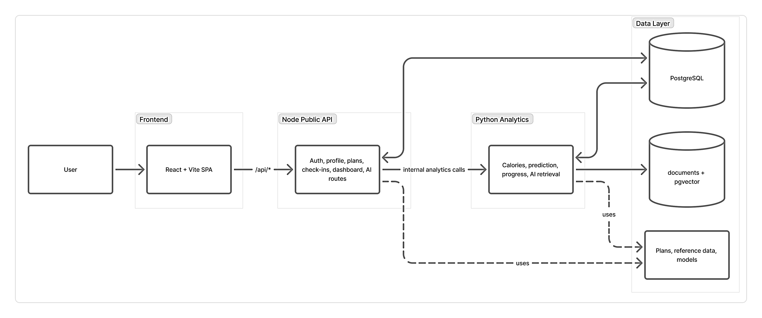
Figure 4.1: Overall System Architecture of the Proposed Personalized Diet-Workout Recommendation System

Layer | Main Responsibility
Frontend Layer | User interaction, forms, dashboards, plan view, and AI coach interface
Node Backend Layer | Authentication, profile management, plan handling, daily check-ins, and progress API exposure
Python Analytics Layer | Calorie estimation, prediction generation, progress summaries, and AI retrieval workflows
Database Layer | Storage of users, logs, plans, snapshots, summaries, and retrieval-related data
Table 4.1: Major architectural layers and their responsibilities.

Frontend Design

The frontend is the user-facing part of the project. It is developed using React and Vite, and its main purpose is to provide a smooth and clear interface through which users can interact with the application. In a project like this, frontend design is not just about appearance. It also affects how easily users can enter data, understand progress, and continue using the system regularly.
The frontend contains separate pages and components for major user flows such as landing, login, registration, profile setup, dashboard view, daily log submission, tracker features, and AI coach interaction. These pages are designed around clear user actions. A new user starts with authentication, completes profile details, selects or views a plan, logs day-to-day information, and then reviews charts, summaries, and AI-based
suggestions.
The current implementation also shows a clear split between the main dashboard and the dedicated tracker experience. The dashboard is designed as a bootstrap screen that pulls plan details, weekly action content, recent check-ins, profile completeness, and chart data in one aggregated response. The tracker page then focuses more deeply on chart reading, summary interpretation, and metric display. This separation improves responsiveness and keeps each screen focused on a smaller user goal.
One of the strengths of the frontend design is that it maps directly to the application workflow. Each page corresponds to a meaningful user task instead of forcing the user through a confusing sequence of menus. For example, the daily log page is connected to the check-in flow, the dashboard is connected to progress review, and the AI coach page is connected to retrieval-based question answering. This direct mapping improves usability and makes the frontend easier to explain in an academic report.
The frontend also acts as the integration point for data returned by the backend services. It receives API responses, displays progress lines, shows summaries, and renders outputs generated by the analytics service. In this way, the frontend is not only an input screen but also the presentation layer for insights produced by the backend system.
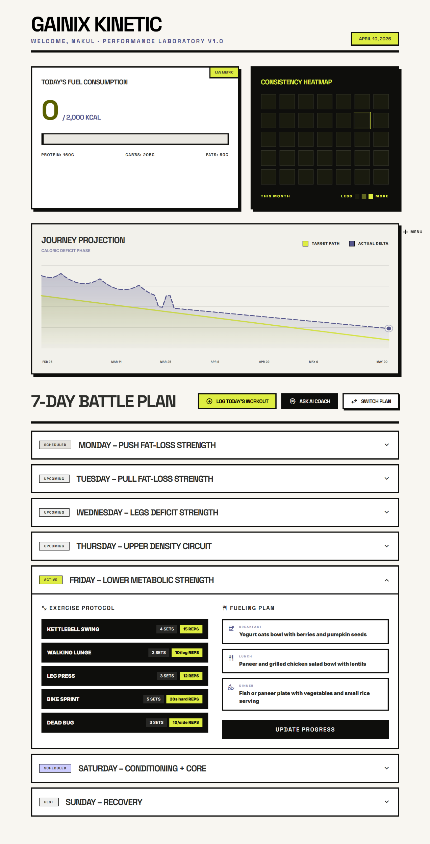
Figure 4.2: Dashboard Interface Showing Aggregated Progress and Plan Information
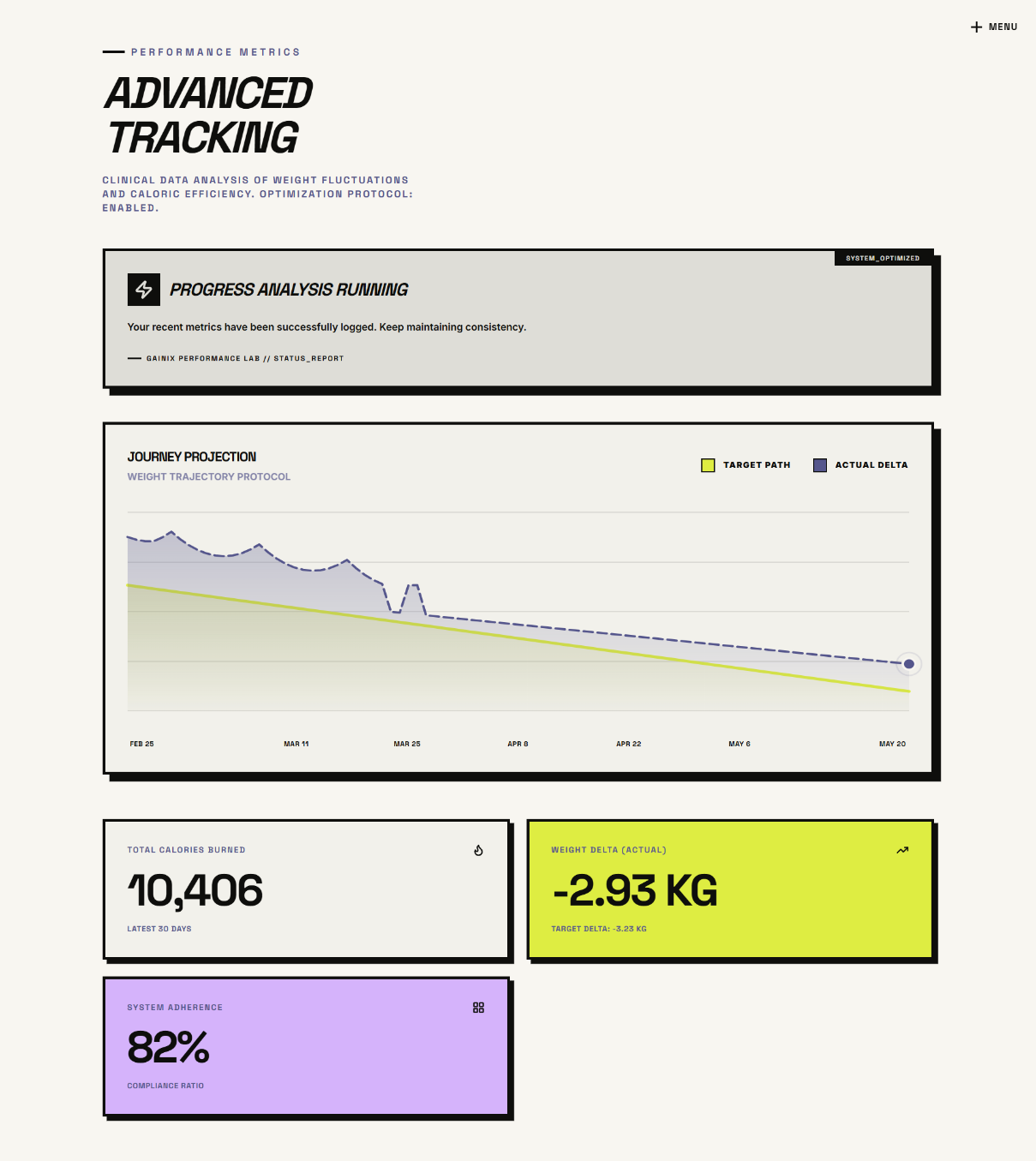
Figure 4.3: Tracker Interface for Check-in History and Progress Interpretation

Backend Node Service Design

The Node backend serves as the main operational API layer of the project. It is built using Node.js, Express, and TypeScript. This layer is responsible for handling requests that are directly related to the user account and the application workflow. It works as the first major backend component that the frontend interacts with.
The responsibilities of the Node backend include user registration, login, token-based authentication, profile update handling, plan retrieval, plan selection, daily check-in recording, dashboard bootstrap aggregation, and progress-related route exposure. It also normalizes public API behavior and provides the contract that the frontend depends on.
Another important role of the Node backend is orchestration. It does not perform every type of analytical computation by itself. Instead, when prediction, summary generation, or AI-based processing is required, it communicates with the Python analytics service.
This division of work makes sense because the Node service is optimized for operational workflows, while the Python service is better suited for analytics and data-oriented logic.
The Node backend interacts with PostgreSQL via Prisma to manage data like users, profiles, sessions, logs, and plans. It also uses Redis caching for read-heavy routes when enabled. As the main public entry point, it ensures the application remains consistent and secure.

Area | Responsibility
Authentication | User registration, login, token management, and  protected route access
Profile Management | Create and update user profile details needed for  personalization
Plan Operations | Expose available plans and store active plan selection
Daily Logging | Receive and validate user check-in data from the  frontend
Dashboard Aggregation | Return a cached bootstrap payload combining plan,  profile, check-ins, and progress data
Progress Integration | Return chart and progress data, including stored  snapshots
Service Orchestration | Forward analytics and AI-related requests to the  Python backend
Cache Layer Support | Reuse Redis-based responses for repeated read-heavy  API calls

Table 4.2: Main responsibilities of the Node backend service.

Backend Python Analytics Design

The Python backend serves as the analytical core of the project, built using FastAPI to handle all computation-heavy and data-oriented tasks. It manages calorie estimation, weight prediction, progress summaries, alternative plan support, and AI-based retrieval logic.
This backend is kept separate from the Node backend because its responsibilities differ significantly. While Node.js handles operational API tasks, the Python backend focuses on analytics, structured processing, and model-driven workflows, making the overall design cleaner and allowing the project to effectively leverage both ecosystems.
One important component of this backend is the prediction engine, which combines standard health formulas like BMR and TDEE with weight projection logic and machine learning to generate ideal and actual progress curves. Another key feature is the AI coach pipeline, where the system gathers profile data, recent logs, and knowledge documents before generating responses.
The Python backend also uses SQLAlchemy and related tools to interact with the shared PostgreSQL database, enabling it to access user logs, profile details, and stored documents required for analytics and retrieval. This design ensures the Python service is not isolated but remains deeply integrated with data generated through regular user activity.

Area | Responsibility
Calorie Analytics | Estimate food intake and workout-related burn values
Prediction Engine | Generate ideal and actual progress trajectories with risk-Related outputs
Progress  Interpretation | Produce summaries, flags, and alternative recommendation  results
AI Coach Support | Retrieve profile, log, and knowledge context for question answer
Database Analytics  Access | Read and reuse stored operational data for analytical processing

Table 4.3: Main responsibilities of the Python analytics service.

Module Interaction Overview

Although the system is divided into layers, the real strength of the design comes from the way these modules interact. The frontend, Node backend, Python backend, and database do not work independently; they support one another through a clear sequence of data flow.
A typical workflow begins when the user interacts with the frontend. The request first reaches the Node backend. If the task is an operational one, such as authentication or profile update, the Node backend handles it directly and stores the result in PostgreSQL. If the task requires analytical processing, such as progress prediction or AI-based explanation, the Node backend sends the request to the Python service. The Python service performs the required analytics, uses the database when necessary, and returns the results. Those results are then passed back through the Node backend to the frontend.
This interaction model gives the project several advantages:

    - it keeps user-facing API logic separate from analytics-specific computation,
    - it allows the database to act as a shared state across both services,
    - it makes future scaling easier because the operational and analytical services can evolve independently.

The design also supports maintainability. If a new prediction model needs to be added, it can be developed mainly in the Python service without rewriting the entire application. If a new frontend screen is introduced, it can consume existing backend contracts without changing the full analytics layer. This modular behavior is one of the strongest aspects of the architecture.
This chapter presented the overall architecture and design of the proposed system, including the purpose of each major layer and the way they interact with one another. The next chapter explains the database design and the complete data flow that supports these architectural decisions.

CHAPTER 5

DATABASE DESIGN AND DATA
FLOW

Database Overview

The database plays a central role in this project because almost every important system feature depends on stored user and application data. Authentication needs persistent user records, daily logging requires structured check-in tables, progress tracking depends on historical records, and the AI coach needs access to stored profile and knowledge information. For this reason, the project uses PostgreSQL as the main database layer.
PostgreSQL was chosen because it is reliable, flexible, and well suited for a project that combines normal application data with analytical and retrieval-oriented storage. It supports structured relational tables, JSON-based fields, indexing, and extension features such as vector storage. These capabilities are useful because the project does not only store plain user data; it also stores logs, prediction snapshots, summaries, recommendation payloads, and knowledge chunks used in AI-based retrieval.
Another important design decision is that both backend services share the same primary database. The Node backend uses Prisma for operational access, while the Python backend uses SQL Alchemy for analytics and data-processing workflows. This shared- database approach keeps operational and analytical data connected, which is essential for a personalized application. A user’s progress chart, for example, becomes meaningful only when profile data, check-in history, and prediction outputs all relate to the same stored records.

Core Tables and Relationships

The database schema is designed around the real application workflow. Instead of using unrelated generic tables, the schema maps directly to major user and system activities such as login, profile completion, plan selection, daily check-ins, prediction generation, and AI-related retrieval support.
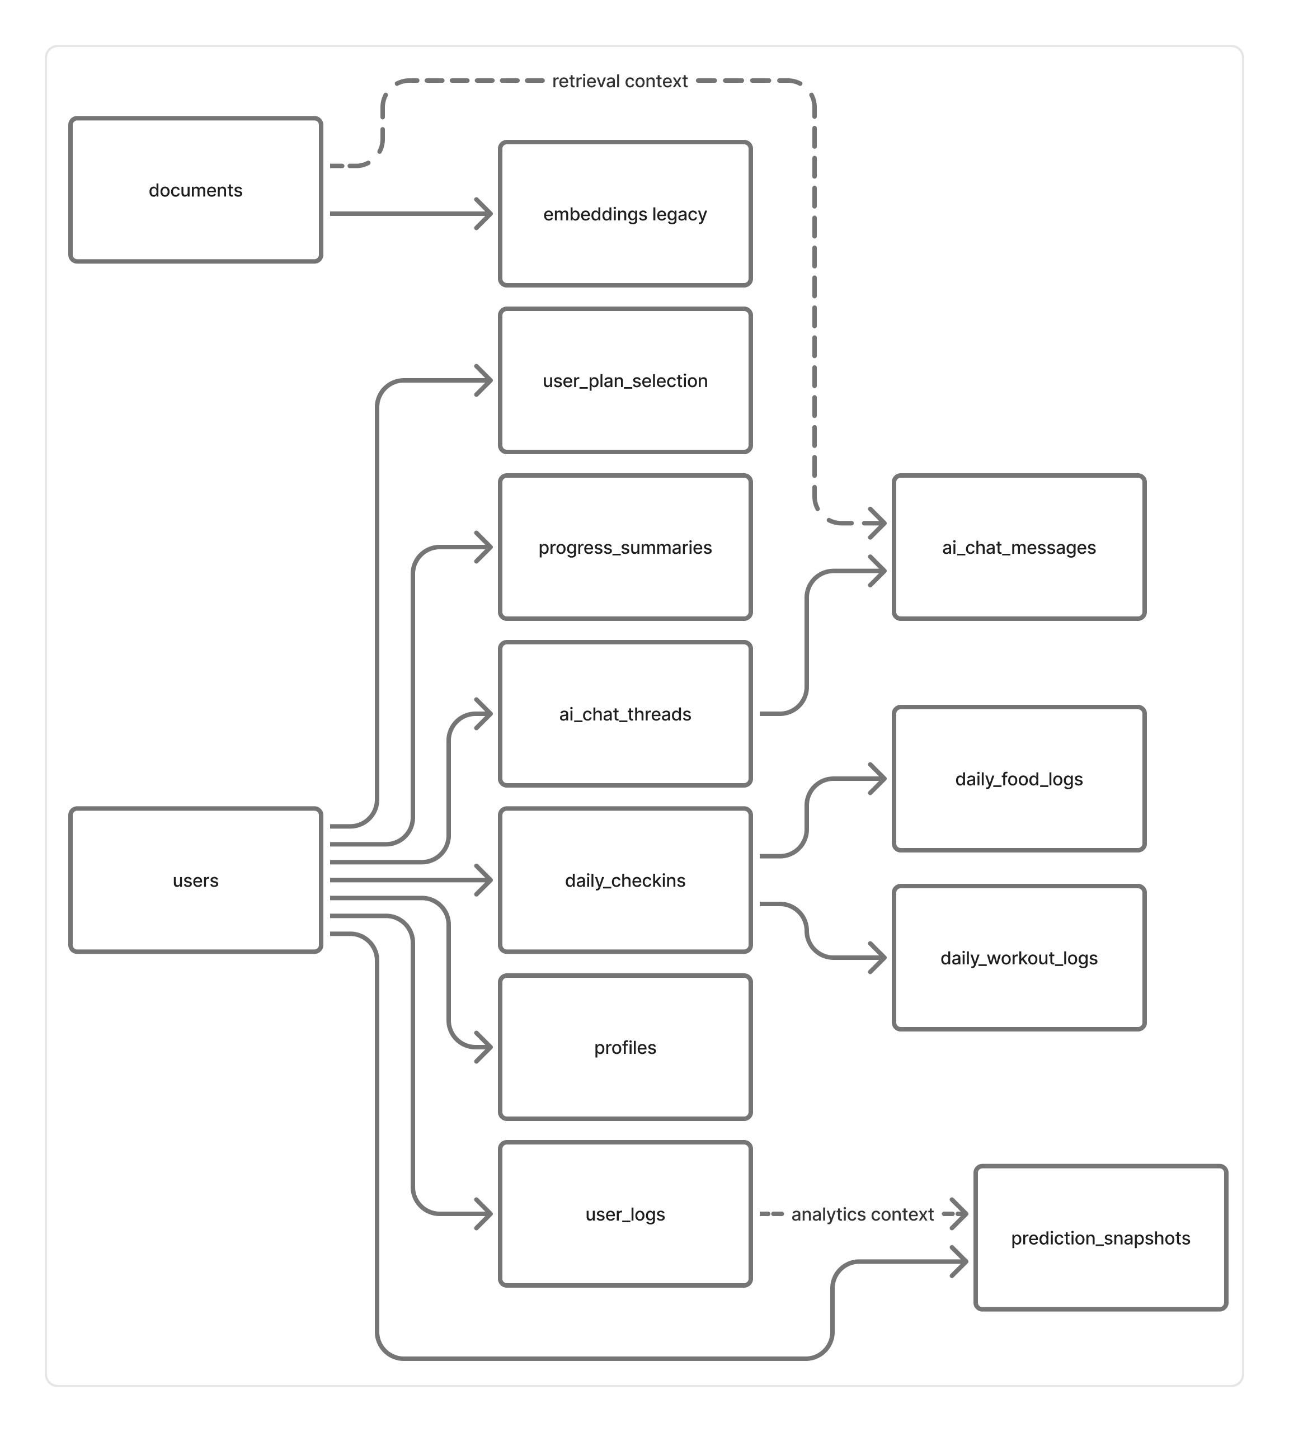
Figure 5.1: Database Relationship Overview of the Implemented System

The user’s table is the core entity, with authentication tables extending it for sessions and verification. The profiles table stores health attributes like age, height, weight, preferences, activity level, and goals for personalization. Plan management is handled through plan catalog and user plan selection, keeping plans reusable and user choices separate. Daily data is organized into check-ins, food logs, and workout logs to maintain structure and simplify analysis. Predictions and recommendations are stored in separate tables to preserve history and improve traceability. For AI retrieval, canonical documents handle knowledge search, while canonical user logs manage user history, ensuring clear separation and effective response generation

Table | Purpose
users | Stores primary user identity information
auth sessions | Stores refresh-session details for authenticated access
profiles | Stores health, goal, and personalization-related profile data
plan catalogue | Stores standard plans available in the application
user plan selection | Stores the active plan selected by each user
daily check-ins | Stores daily progress, adherence, and health measurements
daily food logs | Stores intake mode and food-related daily records
daily workout logs | Stores exercises and calorie-burn-related daily records
prediction snapshots | Stores generated chart lines and risk-related prediction values
progress summaries | Stores summary payloads returned from analytics endpoints
plan recommendations | Stores generated recommendation or alternative-plan outputs
documents | Stores vector-ready knowledge chunks for semantic AI retrieval
user logs | Stores temporal user activity summaries used in retrieval workflows

Table 5.2: Core tables used in the application database.

Operational Data Flow

Operational data flow refers to the normal application flow followed by the user from authentication to daily usage. This is the part of the system that is most visible to the end user. The flow begins with registration and login, then moves to profile setup, plan selection, and daily check-in submission.
When a user logs in or registers, the request is handled by the Node backend, and the related records are stored in authentication and user tables. After that, the user completes the profile. This profile data is important because later recommendation and prediction steps depend on these values. If the profile is incomplete, the personalization quality of the system drops.
Once a plan is selected, the user begins regular interaction through daily check-ins. On each day, the user may submit weight, calorie intake, workout details, sleep, steps, and adherence-related information. These inputs are validated at the API level and then stored in the relevant daily logging tables. This operational flow is the foundation for all later analytics.
What makes the design stronger is that operational data is not treated as static history. It immediately becomes useful for progress generation and AI support. This means the operational data flow is directly connected to the analytical layer rather than being stored passively.

Prediction and Snapshot Data Flow

Prediction data flow begins when the system needs to convert stored user history into meaningful progress output. This usually happens when the user opens the progress chart, requests a summary, or submits new daily check-in data that changes the expected outcome.
The Node backend first checks whether suitable prediction snapshots already exist. If they are available and valid, they can be returned directly to avoid unnecessary recomputation. If not, the Node backend forwards the request to the Python analytics service. The Python service then uses stored profile and check-in data to calculate progress outputs such as ideal line, actual line, deviation score, and risk flags.
After computation, the generated outputs may be stored back into snapshot-oriented tables such as prediction snapshots, progress summaries, or plan recommendations. This step is important because it creates a record of analytical outputs over time. In- stead of treating predictions as temporary values only, the system preserves them in a structured way for later access, comparison, and debugging.
This design improves both usability and engineering quality. From the user side, chart and summary retrieval becomes smoother. From the system side, it supports traceability and repeatability.

Artifact | Stored Content
prediction snapshots | Ideal line, actual line, deviation score, and risk flags
progress summaries | Generated summary payloads and progress interpretation
plan recommendations | Alternative suggestions and recommendation payloads

Table 5.4: Prediction-related data artifacts stored by the system.

AI Retrieval Data Flow

The AI retrieval data flow is one of the most interesting parts of the project because it connects user-specific information with knowledge-based content. When a user sends a question through the AI coach interface, the request first reaches the Node backend. The Node service authenticates the request and forwards it to the Python analytics backend.
The Python backend then performs intent classification to understand what kind of question has been asked. After that, it retrieves context from multiple sources. These typically include profile details, recent user logs, and stored knowledge chunks from a vector-backed document or embedding store. The retrieved information is then merged into a unified context used to generate the final answer.
This flow ensures AI responses are grounded in user data rather than generic, making them more meaningful, explainable, and relevant. This chapter covered the database structure and data flow, while the next focuses on dataset preparation and feature engineering for analytics and prediction.

CHAPTER 6

DATASET PREPARATION AND FEATURE ENGINEERING

Plan Dataset Preparation

The analytical part of this project depends on more than just live user data. To support prediction workflows, model development, and controlled experimentation, the project includes a synthetic dataset generation pipeline. This pipeline creates structured plan- based datasets that imitate realistic diet and workout tracking patterns over time.
The generated datasets are organized at the plan level. In the current implementation, there are six major plan datasets:
    - vegan weight gain,
    - vegan weight loss,
    - non-veg weight gain,
    - non-veg weight loss,
    - mixed diet weight gain,
    - mixed diet weight loss.
Each dataset contains records for 300 synthetic users tracked over 90 days. This gives 27,000 rows per file and a total of 162,000 rows across all six files. The row granularity is one record per user per date, which makes the datasets suitable for time-based feature extraction and horizon-based prediction tasks.
The generation process is deterministic, which is an important design choice. A fixed seed is used so that dataset creation can be repeated reliably. This improves reproducibility and makes the project more suitable for academic analysis. If the generated data changes on every run, then model behavior and output comparison become harder to justify.
Another strong point of the dataset preparation workflow is that it does not generate arbitrary values without logic. The synthetic records are built using health-oriented formulas and safety-aware ranges. For example, BMR and TDEE estimates are used as a basis for calorie planning, goal type influences whether the system models a safe surplus or deficit, and expected versus actual weight is integrated using energy-balance logic. This helps the synthetic data behave more like realistic structured health data rather than random numbers.

Dataset | Users | Rows
vegan-weight-gain.csv | 300 | 27,000
vegan-weight-loss.csv | 300 | 27,000
non-veg-weight-gain.csv | 300 | 27,000
non-veg-weight-loss.csv | 300 | 27,000
mixed-diet-weight-gain.csv | 300 | 27,000
mixed-diet-weight-loss.csv | 300 | 27,000
Table 6.1: Summary of synthetic plan datasets used in the project.

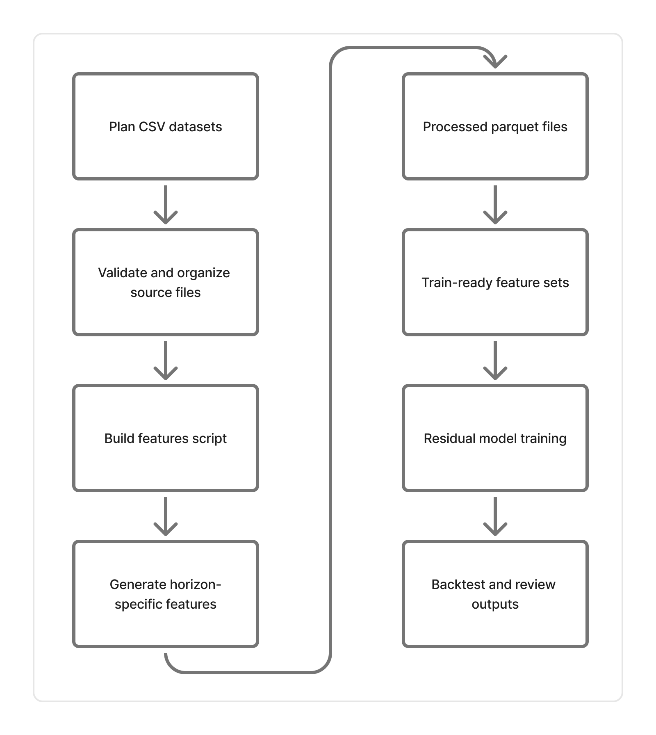
Figure 6.1: Feature Engineering Workflow Used for the Prediction Pipeline

Reference Data Sources

Along with the main plan datasets, the project uses supporting reference datasets that provide domain-level values needed during generation and later analytical processing. These reference files help ensure that food and exercise values remain consistent with the expected logic of the application.
Two important reference files are used in the current workflow:

- Indian food calories.csv, which contains calorie-related information for food items,
- exercise calorie reference.csv, which contains calorie burn rates for different exercises.

These references are especially useful because the project is not limited to abstract calorie numbers. Instead, it tries to connect intake and burn values with more meaningful food and exercise categories. This improves the realism of both the generated datasets and the later feature engineering process.
The project also includes generated plan documents and knowledge documents. Plan documents describe weekly structures, meal patterns, and workout logic for the six supported plans. Knowledge documents cover supporting health topics such as protein guidance, fat loss principles, muscle gain principles, progressive overload, metabolic adaptation, injury prevention, and calorie mathematics. These documents later become useful for AI retrieval workflows through chunking and semantic storage.

Feature Engineering Workflow

Feature engineering is the stage where raw plan-level data is converted into model-ready analytical input. This is one of the most important steps in the project because prediction quality depends not only on the model, but also on whether the features capture the right behavior over time.
The feature-building script standardizes input columns, normalizes plan files, and then computes time-aware derived values. Instead of using only current-day values, the project creates rolling and trend-based features so that the model can understand recent patterns. This is important because human progress in diet and workout routines depends heavily on short-term consistency, not just on isolated daily entries.
Some of the important engineered features used in the project include:

- rolling mean of net calories over 7 and 14 days,
- rolling standard deviation of recent calorie balance,
- rolling average adherence over 7 days,
- short-term weight trend using slope over 14 days,
- average recent steps and sleep duration,
- recent workout-completion behavior,
- day count since plan start,
- day-of-week information,
- physics-based baseline weight for the current date.

One strong design choice in the feature pipeline is that it is leakage-safe. Features are computed using shifted historical data so that the model does not accidentally learn from future values while predicting future outcomes. This is especially important in time- series-style health prediction because careless feature construction can make a model appear much better than it actually is.
After the base features are prepared, target residuals are added for different horizons such as 7, 14, and 30 days. These residual targets represent the gap between future observed weight and the physics-based baseline. This allows the machine learning model to learn adjustments on top of a deterministic baseline rather than replacing health logic entirely.

Data Validation and Consistency Checks

Once datasets and engineered features are created, validation becomes necessary. With- out a validation stage, errors in row counts, missing columns, unrealistic values, or inconsistent goal direction could silently affect the quality of predictions and recommendations.
The project includes explicit validation rules for the generated plan datasets. These checks verify that required columns are present, row counts match expectation, dates remain continuous for each user, calorie values are not negative, and nutritional relation- ships remain within acceptable tolerance. Goal-direction consistency is also checked. In other words, weight-gain plans should generally show a positive trend by the end of the horizon, while weight-loss plans should generally show a negative trend.
The project also keeps supporting artifacts such as manifests, data dictionaries, generation summaries, seed files, and consistency reports. These are useful from both an engineering and academic perspective. They make the data pipeline easier to audit and demonstrate that the project is reproducible rather than manually assembled without structure.
Another important part of consistency checking is alignment between plan documents and generated datasets. The project attempts to ensure that the logic described in human- readable plan documents is consistent with the numerical data generated for those plans. This is particularly valuable because the same plan content later contributes to AI retrieval workflows.
This chapter explained how the project prepares synthetic plan data, uses reference sources, builds prediction-ready features, and validates the resulting artifacts. The next chapter focuses on the prediction engine and recommendation methodology that operate on top of this prepared data.

CHAPTER 7

PREDICTION ENGINE AND RECOMMENDATION METHODOLOGY

Calorie Intake and Burn Estimation

The prediction and recommendation part of the project begins with basic energy-related quantities. Before the system can estimate progress, it must first understand how much energy the user consumes and how much energy the user spends. In this project, these two values are treated as calorie intake and calorie burn.
Calorie intake is derived from user food input. The system supports more than one way of recording intake. A user may provide direct calorie information or enter food items that are then mapped to calorie values through reference data. This flexibility is useful because different users prefer different logging styles. Some want quick direct entry, while others want item-level food records.
Calorie burn is estimated from workout and activity inputs. Exercise-related calorie references, step count, and workout completion details help the system approximate how much energy the user has spent. These values are later combined with profile and metabolic information so that the system can understand whether the user is in a calorie deficit, calorie surplus, or maintenance zone.
The importance of this stage should not be underestimated. If intake and burn values are poor, every later prediction step becomes weaker. For that reason, the project uses structured logging and reference-based support rather than depending only on rough user guesses.
Input Type | Purpose in System
Food Intake Data | Calculates daily calorie intake based on consumed food items
Exercise Entries | Determines calories burned through different workout activities
Steps Count | Reflects overall daily movement and contributes to activity-level estimation
Workout Completion Percentage | Measures adherence to the planned workout routine
Profile Data | Provides user-specific details (age, weight, goals) for personalized estimation
Table 7.1: Inputs used for calorie-related estimation in the project.

BMR and TDEE Computation

After intake and burn inputs are available, the system calculates the user’s baseline metabolic requirement. This is done through BMR and TDEE estimation. These two values form the foundation of the deterministic prediction layer.
BMR, or Basal Metabolic Rate, represents the approximate energy the body needs at rest to maintain essential biological functions. In this project, BMR is calculated using the Mifflin-St Jeor equation. This formula is widely used in health and fitness applications because it is simple, interpretable, and practically useful. The project supports male, female, and other values in a deterministic manner.
TDEE, or Total Daily Energy Expenditure, extends BMR by including the effect of daily activity. The system applies an activity multiplier to the BMR value in order to estimate how much energy the user needs in a normal day. This is important because two users with similar weight and height may still need very different calorie recommendations if one is sedentary and the other is physically active.
In this project, BMR and TDEE are not treated as isolated display values. They directly influence weight projection, net-calorie planning, and later progress interpretation. That is why this step is one of the central parts of the prediction methodology.
The BMR equation used in the code is based on the following logic:

    - male: 𝐵𝑀𝑅 = 10𝑊 + 6.25𝐻 − 5𝐴 + 5

    - female: 𝐵𝑀𝑅 = 10𝑊 + 6.25𝐻 − 5𝐴 − 161

    - other: a neutral deterministic offset is used for stable computation

where 𝑊 is weight in kilograms, 𝐻 is height in centimeters, and 𝐴 is age in years.

Weight Projection Logic

Once BMR and TDEE are available, the system can project future weight based on energy balance. This deterministic projection acts as the baseline prediction line in the project. The central assumption used here is the widely known approximation that 7700 kilocalories correspond to about 1 kilogram of body weight change.
The project uses planned net calories per day to generate an ideal weight trajectory. If the daily net energy is negative, the model expects weight loss over time. If the daily net energy is positive, it expects weight gain over time. By integrating this daily difference over a period of days, the system generates an ideal line that represents what should happen under consistent plan-following conditions.
This baseline is very important because it gives the system a transparent and explainable starting point. Instead of immediately jumping into black-box model outputs, the project first creates a physics-style expectation. This makes it easier to explain why the predicted chart looks the way it does and how real outcomes differ from ideal ones.
The system also uses check-in-calibrated prediction logic. Recent user history is sorted, validated, and analyzed to understand adherence level, trend gap, and net-calorie variation. This means the actual projected line is not just a random modification of the ideal line. It is adjusted using recent user behavior and short-term patterns.

Residual Machine Learning Models

While deterministic weight projection is useful, it does not fully capture the complexity of real user behavior. People do not follow plans perfectly every day. Their adherence varies, daily fluctuations occur, and the same calorie target may affect different users differently. Because of this, the project includes residual machine learning support on top of the deterministic baseline.
The idea behind the hybrid approach is simple: first generate a sensible baseline using health formulas, and then let the machine learning model learn the remaining adjustment. In other words, the model predicts the residual difference between actual future weight and the baseline projection. This is more stable and interpretable than asking the model to predict everything from scratch.
The project uses leakage-safe features and trains residual models for multiple horizons such as 7, 14, and 30 days. Quantile models are also used so that the system can provide not only a median prediction but also lower and upper bands. In the final output, this appears as a predicted median line and an uncertainty interval between p10 and p90. This is a better design than returning one hard number without any notion of confidence.
Another practical strength of this approach is that it supports fallback behavior. If suitable models are unavailable, the system can still return a deterministic baseline instead of failing completely. This improves reliability and makes the prediction engine more robust in a real application setting.

Output | Meaning
Ideal Line | Deterministic physics-based trajectory from energy balance
Predicted Median Line | Hybrid prediction using residual model plus baseline
P10 Line | Lower quantile estimate representing a conservative range
P90 Line | Upper quantile estimate representing an optimistic range
Provenance Metadata | Model version, source, and input-related traceability information

Table 7.3: Prediction outputs supported by the hybrid pipeline.
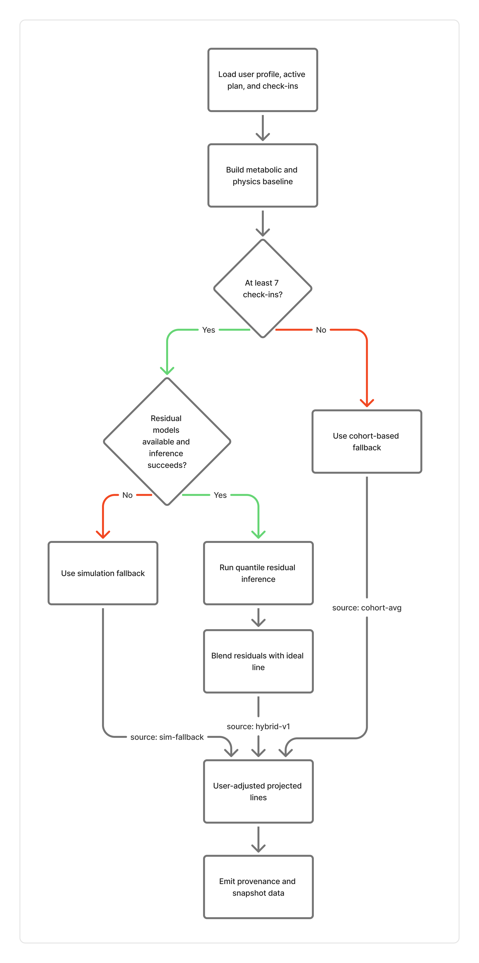
Figure 7.1: Hybrid Prediction Pipeline from Metabolic Baseline to User-Adjusted Projection

Deviation Score and Risk Flags

Prediction becomes much more useful when the system can explain whether the user is close to the expected path or drifting away from it. This is the role of deviation scoring and risk flag generation in the project.
The deviation score is used to measure the gap between the ideal line and the actual projected line. Instead of checking just the final point, the system looks at the difference across recent values and calculates a deviation-oriented metric. This helps identify whether the user is consistently off track, even if the final weight has not yet moved dramatically.
Risk flags provide an additional interpretive layer. These flags are generated when the system notices patterns such as large deviation, too-fast weight change, aggressive calorie planning, or strong drift between actual and ideal end points. These flags are useful because they convert numerical differences into readable warnings that can later be shown in dashboards or used in summaries.
This part of the prediction system is especially valuable from a user perspective. People generally understand labels such as “large deviation” or “aggressive calorie plan” more easily than a raw list of numbers. It also helps the system produce smarter recommendations and better AI explanations.
Signal | Purpose
Deviation Score | Measures how far actual progress deviates from  the expected line
Large Deviation Flag | Highlights strong mismatch between ideal and  actual trends
Too-fast Weight Change Flag | Indicates potentially unrealistic or unsafe rate of  change
Aggressive Calorie  Plan Flag | Warns about extreme planned net-calorie  values
Endline Drift Flag | Shows that actual projection diverges strongly  from the ideal endpoint

Table 7.4: Examples of interpretation signals generated by the prediction layer.

CHAPTER 8

AI COACH AND PERSONALIZATION
LOGIC

AI Coach Module Overview

The AI coach module is one of the most user-visible parts of the project. Its purpose is to allow users to ask questions in natural language and receive useful responses related to progress, diet, workout behavior, and overall plan quality. Instead of forcing users to understand charts or raw metrics on their own, the AI coach provides a more conversational way to interpret what is happening.
What makes this module important is that it is not designed as a generic chatbot. A normal chatbot can answer broad health questions, but it cannot always explain the user’s actual situation. In this project, the AI coach is built to combine profile information, recent user history, and stored knowledge content. This makes the final answer more grounded and more personal.
The AI coach workflow begins when a user sends a question from the frontend. That request moves through the Node backend and reaches the Python analytics service. The Python backend then performs routing, retrieval, synthesis, and final response generation. Each of these steps is important because the system is trying to answer not only fluently, but also meaningfully.
Another practical strength of this design is that it supports both general knowledge questions and user-specific questions. A user may ask about calories, protein, weight plateau, workout consistency, or personal progress trends. The module is designed to choose the right type of context before generating the response.
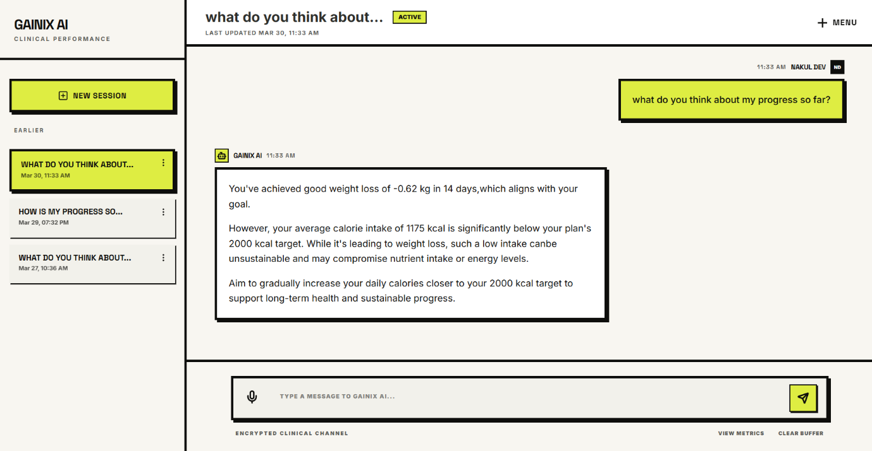

Figure 8.1: AI Coach Interface for Personalized Question-Answer Support

Intent Classification

The first analytical step in the AI workflow is intent classification. Before the system retrieves any context, it tries to understand what type of question the user is asking. In the current design, questions are classified into three broad categories:

    - ANALYTIC, when the question is mainly about the user’s own data,

    - KNOWLEDGE, when the question is mainly general or educational,

    - HYBRID, when the question mixes user context with knowledge-based guidance.

This classification matters because not every question requires the same data source. A purely knowledge-oriented question may depend more on health documents, while an analytic question should depend more on user logs and profile data. A hybrid question often needs both. By making this distinction early, the system avoids unnecessary retrieval and improves the quality of the final answer.
The project uses a rule-based heuristic approach with optional model-assisted routing support. It also extracts entities such as dates, exercise-related terms, and food-related terms from the user question. These extracted signals later help decide which logs or knowledge chunks are most relevant.

Intent Type | Meaning
ANALYTIC | The question focuses mainly on user  logs, trends, or recent performance
KNOWLEDGE | The question focuses mainly on general health or fitness explanation
HYBRID | The question needs both domain  knowledge and user-specific context

Table 8.1: Intent types used in the AI coach module.

Multi-Stream Retrieval Pipeline

After intent classification, the system enters a retrieval phase that uses a multi-stream design instead of a single context source, which is especially effective for health-related queries. It combines three streams: a semantic stream that pulls relevant information from stored documents for general guidance, a temporal stream that analyzes recent user logs (typically the last 14 days) to summarize activity and trends, and a profile stream that incorporates user goals, preferences, and health conditions.
By merging these streams, the system produces responses grounded in both knowledge and personal context, making them far more meaningful than generic answers generated from model memory alone.
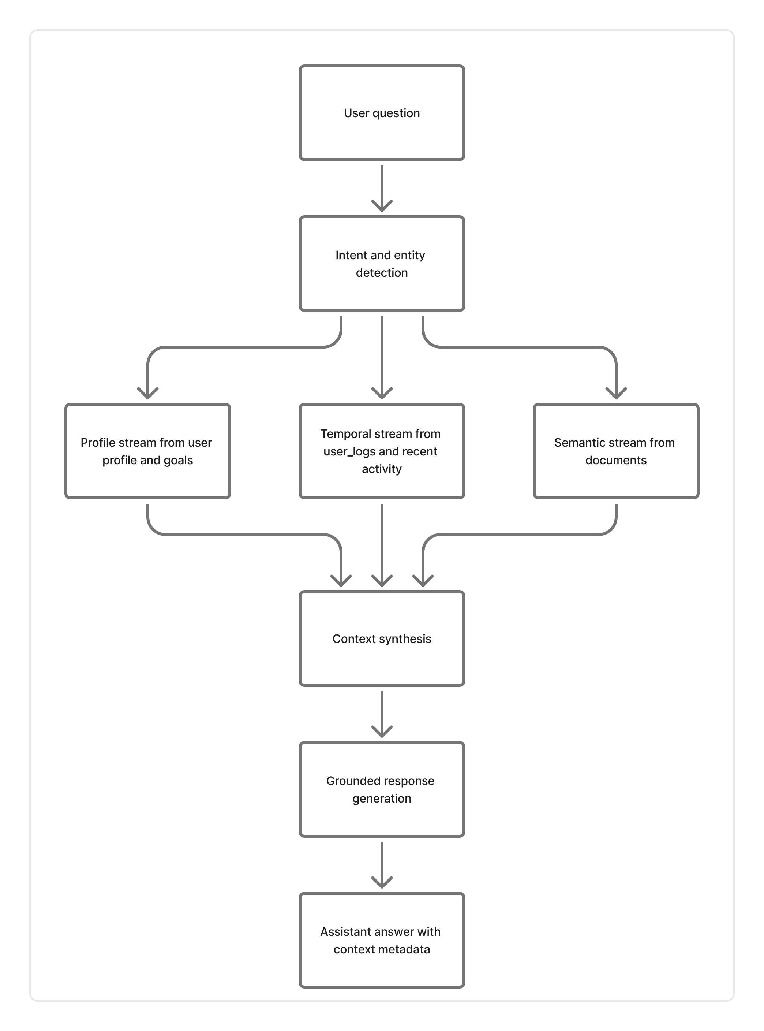
Figure 8.2: Multi-Stream Retrieval Workflow Used by the AI Coach

Context Synthesis

Retrieval alone does not solve the problem. The system still needs to transform multiple pieces of evidence into one clean and usable context for the generation step. This is the purpose of context synthesis.
In this project, the retrieved content is merged into a single unified context string. The unified format combines three major elements: research base, user performance, and profile. The research base comes from retrieved knowledge chunks, user performance comes from temporal summaries of recent logs, and profile comes from goal and preference information.
The system also checks whether enough user data is available. If logs are missing or insufficient, the system explicitly marks user data sufficiency as low. This is a very important feature because it prevents the AI coach from pretending to know details that are not actually available. Instead, it can shift toward giving a more general but still useful answer.
Another interesting part of context synthesis is the calorie delta logic. If the system finds a target calorie value in retrieved research content and also has usable user log data, it calculates the difference between target calories and actual average calories. This gives the final response a more practical and personalized explanation.
The synthesis stage therefore acts as the bridge between retrieval and generation. Without it, the AI coach would only have a loose collection of facts instead of a structured understanding of the user’s situation.

Grounded Response Generation

The final stage of the AI coach pipeline is response generation. After the unified context is created, the system sends the user question and the synthesized context to the language model layer. The response is then cleaned, validated, and returned through the API.
One of the strongest aspects of this design is that generation happens only after retrieval and synthesis. This means the model is not encouraged to answer freely without context. Instead, it is guided by structured evidence. In health-related applications, this is an important safety and quality consideration because users may rely on the answer to make decisions about diet or exercise.
The project also includes response-guard behavior. If model output is incomplete or if a problematic finish reason occurs, the system can retry with a more controlled configuration. It also sanitizes forbidden internal terms and ensures that the final response ends like a complete sentence. These small details improve professionalism and help the user experience feel more polished.
Another useful part of the design is the metadata returned with the response. The API stores or returns information such as request ID, question intent, grounding mode, user data sufficiency, finish reason, recovery usage, and output validation status. These metadata fields are valuable for debugging, evaluation, and future improvement of the AI module.
Overall, the AI coach in this project is not simply an added chatbot feature. It is a structured personalization layer built on top of profile data, log summaries, and
knowledge retrieval. This makes it more consistent with the overall goal of the system to provide meaningful, explainable, and user-centered digital health support.
This chapter explained how the AI coach works, from intent classification to multi- stream retrieval, unified context synthesis, and grounded response generation. The next chapter moves to implementation details and API workflows that connect all modules of the system in practice.

CHAPTER 9

IMPLEMENTATION DETAILS AND API WORKFLOWS

Authentication and Profile Flow

The implementation of the system begins with user identity and profile management. These two parts are fundamental because almost every personalized feature depends on them. Without proper authentication, the system cannot safely associate logs and pre- dictions with the correct user. Without profile data, the recommendation and prediction quality becomes limited.
The authentication layer is implemented in the Node backend using Express routes and controller-based logic. The project supports registration, login, token refresh, logout, and user-detail retrieval. Authentication requests are validated using JSON schema validation before they reach the business logic. This improves reliability because malformed or incomplete payloads are rejected early.
Once a user is authenticated, profile management becomes the next important workflow. The frontend collects profile data such as age, height, weight, activity level, goal, food preference, and related fields. This data is then sent to the Node backend through protected routes. The backend validates the payload and updates the corresponding profile record in the database.
This flow is very important because later features such as plan selection, progress prediction, and AI guidance all depend on profile completeness. In fact, the project design intentionally links profile quality with downstream usefulness. A better profile leads to better personalization.

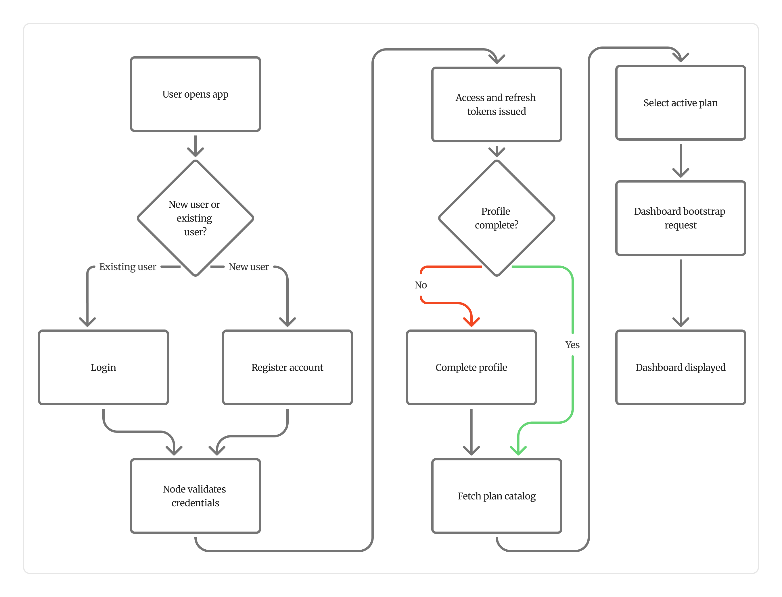
Figure 9.1: User Flow from Registration and Login to Dashboard Access

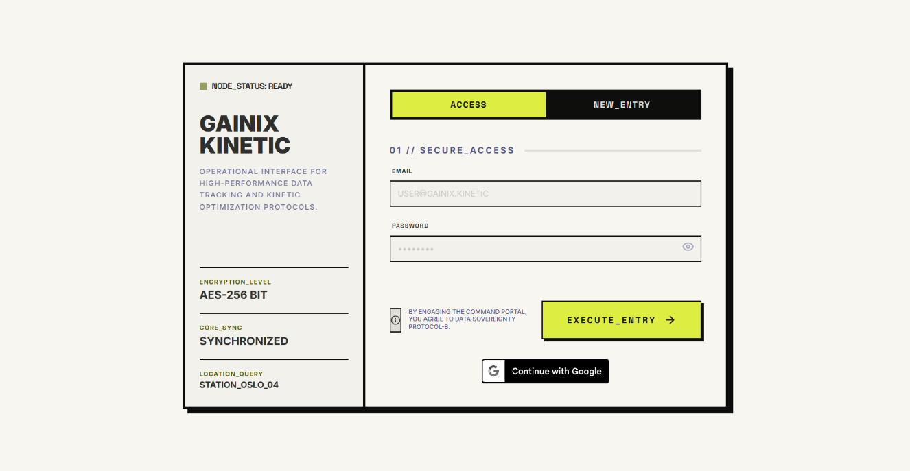

Figure 9.4: Login and Registration Interface of the System
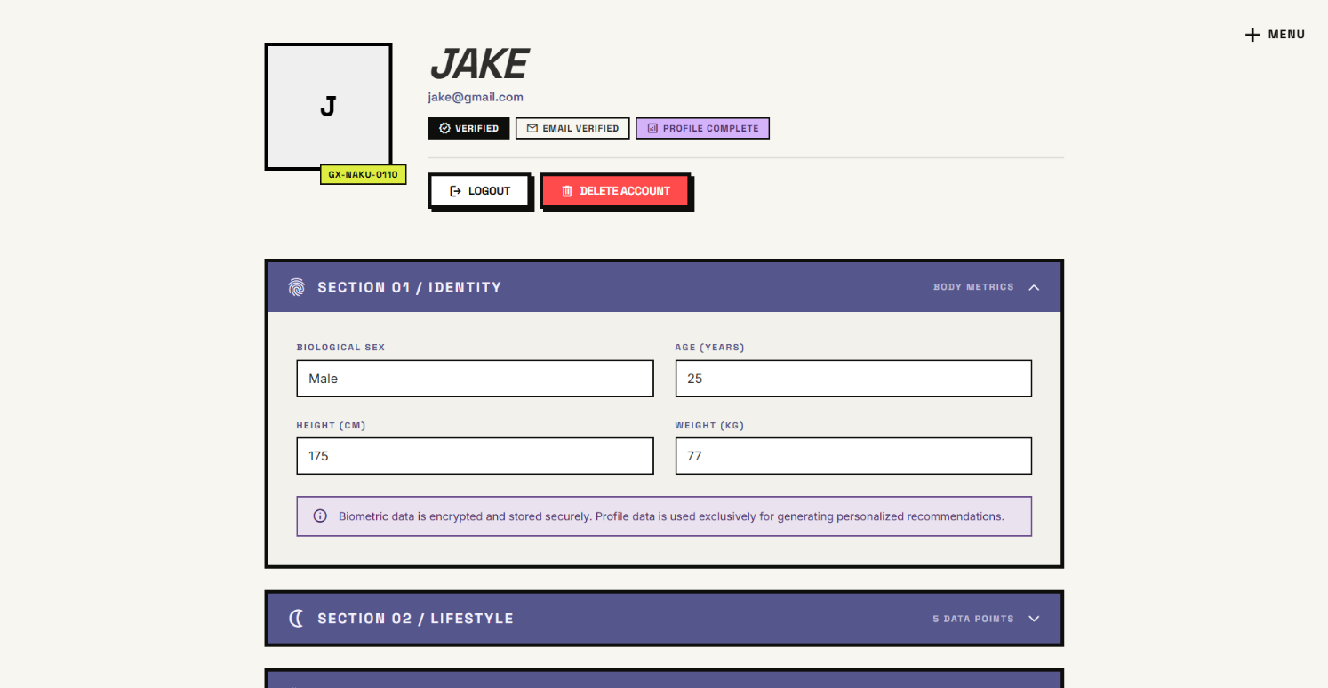

Figure 9.5: Profile Setup Interface for User Personalization

Plan Selection and Daily Check-In Flow

After authentication and profile setup, the user moves into the actual health-management workflow. This begins with plan selection and continues through daily check-ins. These two steps are closely connected because the selected plan gives the system a baseline structure, while the daily check-ins show how the user is really behaving.
The plan flow works by exposing plan data through the backend and storing a user’s active selection in the database. This allows the system to know which plan the user is currently following. Plan identity later becomes important for summary generation, prediction support, and recommendation adjustments.
The daily check-in workflow is one of the most important implemented flows in the project. A check-in may include weight, height, sleep, steps, workout completion, intake details, and workout information. The Node backend validates the payload and writes the data into structured daily tables. Depending on the request path and system needs, these records can later be used for calorie calculations, prediction updates, and progress summary generation.
From an implementation perspective, this flow is well structured because it separates intake data, workout data, and overall daily check-in records. That makes the stored information easier to query and reuse later in analytics.
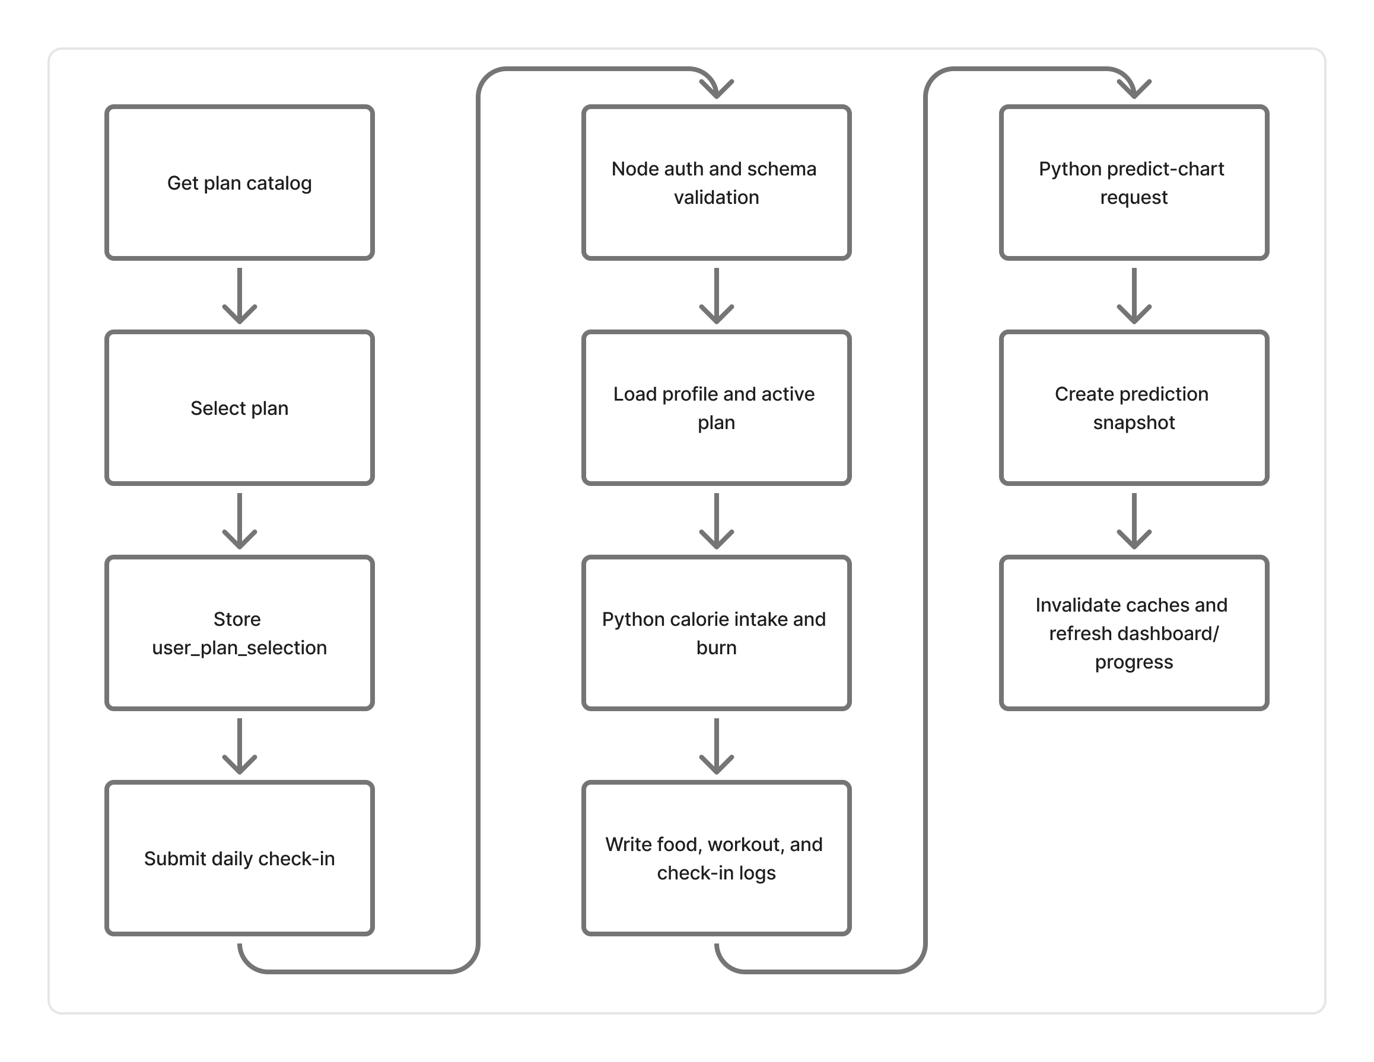
Figure 9.2: Plan Selection and Daily Check-in Flow in the Implemented System

Endpoint | Method | Purpose
/api/plans | GET | Fetch available plans from the catalogue
/api/checkins/daily | POST | Submit a daily health and activity check-in
/api/checkins/{date} | GET | Retrieve the stored daily check-in for a given  date

Table 9.2: Important plan and daily check-in endpoints.

Progress Chart and Summary Flow

Progress review is one of the most meaningful features of the system because it converts stored user history into visible insight. The user should not only be able to log daily data
but also understand what that data is leading to. For this reason, the project includes chart generation, summary generation, and predictive flow integration.
In the current implementation, the frontend does not depend only on isolated progress endpoints. The dashboard first calls a bootstrap route that aggregates current plan selection, weekly action-plan content, profile completeness, recent check-ins, and progress chart information into one response. This reduces the number of separate initial requests needed by the frontend and keeps the main dashboard screen faster and more coherent.
When the user requests progress-related output, the Node backend acts as the coordinator. It checks stored information and either returns available values or calls the Python analytics service for heavier computation. The Python side may generate predicted chart data, progress summaries, or deviation-related outputs. These results are then stored or returned back through the Node backend to the frontend.
One useful implementation detail is the presence of snapshot logic. If a valid prediction snapshot already exists, the system can reuse it instead of recomputing everything. This improves efficiency and provides a more stable user experience. If no valid snapshot exists, the backend triggers the necessary analytics workflow and then persists the result.
Another useful implementation detail is route-level caching in the Node service. The dashboard bootstrap endpoint uses a short-lived cache so that repeated dashboard refreshes within a short time window do not repeatedly reconstruct the same payload. This is a practical engineering decision because dashboard data is read often, but it does not need to be recomputed on every single request.
The summary flow is especially important because it transforms raw history into readable insights. Instead of only showing a weight line, it can also provide average adherence, total calories burned, net calorie trend, weight change, and flags that describe the user’s current status more clearly.

Alternative Plan Workflow

Not every user will continue progressing well under the first selected plan. Because of this, the project includes support for alternative plan generation. This workflow is useful when the current plan is not producing the expected trend or when the user explicitly requests alternatives.
In the implementation, the alternative-plan workflow depends on user context, recent metrics, and the available plan catalog. The Node backend provides the route that the frontend consumes, while the Python analytics service handles the logic required to generate recommendation candidates. The resulting alternatives may also be stored in the database for later reuse or comparison.
This workflow is an important addition because it makes the system more adaptive. Instead of assuming that one chosen plan is always correct, the application can respond to changing user outcomes and propose more suitable options. From a project perspective, this improves the practical value of the recommendation engine.

AI Question-Answer Workflow

The AI question-answer flow connects the frontend user experience with the retrieval and generation logic explained in the previous chapter. From the implementation point of view, this workflow begins in the frontend when the user submits a question through the AI coach interface. The request is then sent to the Node backend route dedicated to AI interaction.
The Node backend performs several important checks before forwarding the question. It validates that a usable user ID is available, ensures that the question length is acceptable, and applies rate limiting to protect the service. Once the request passes validation, it is forwarded to the Python analytics backend, where the multi-stream retrieval and grounded generation process takes place.
After the Python service completes the orchestration, the generated answer and related metadata are returned through the Node backend and then displayed in the frontend. The workflow also includes feedback support, which allows the application to record user opinion about the AI response. This is useful from an engineering standpoint because it creates a path for future monitoring and improvement.
This implemented flow is valuable because it demonstrates how a conversational feature can be integrated into a structured health application without making it feel disconnected from the rest of the system.

This chapter described how the system is implemented in practice through authentication, profile handling, plan selection, daily check-ins, progress workflows, alternative-plan generation, and AI question answering. The next chapter evaluates the system through testing, validation, observations, and discussion of results.
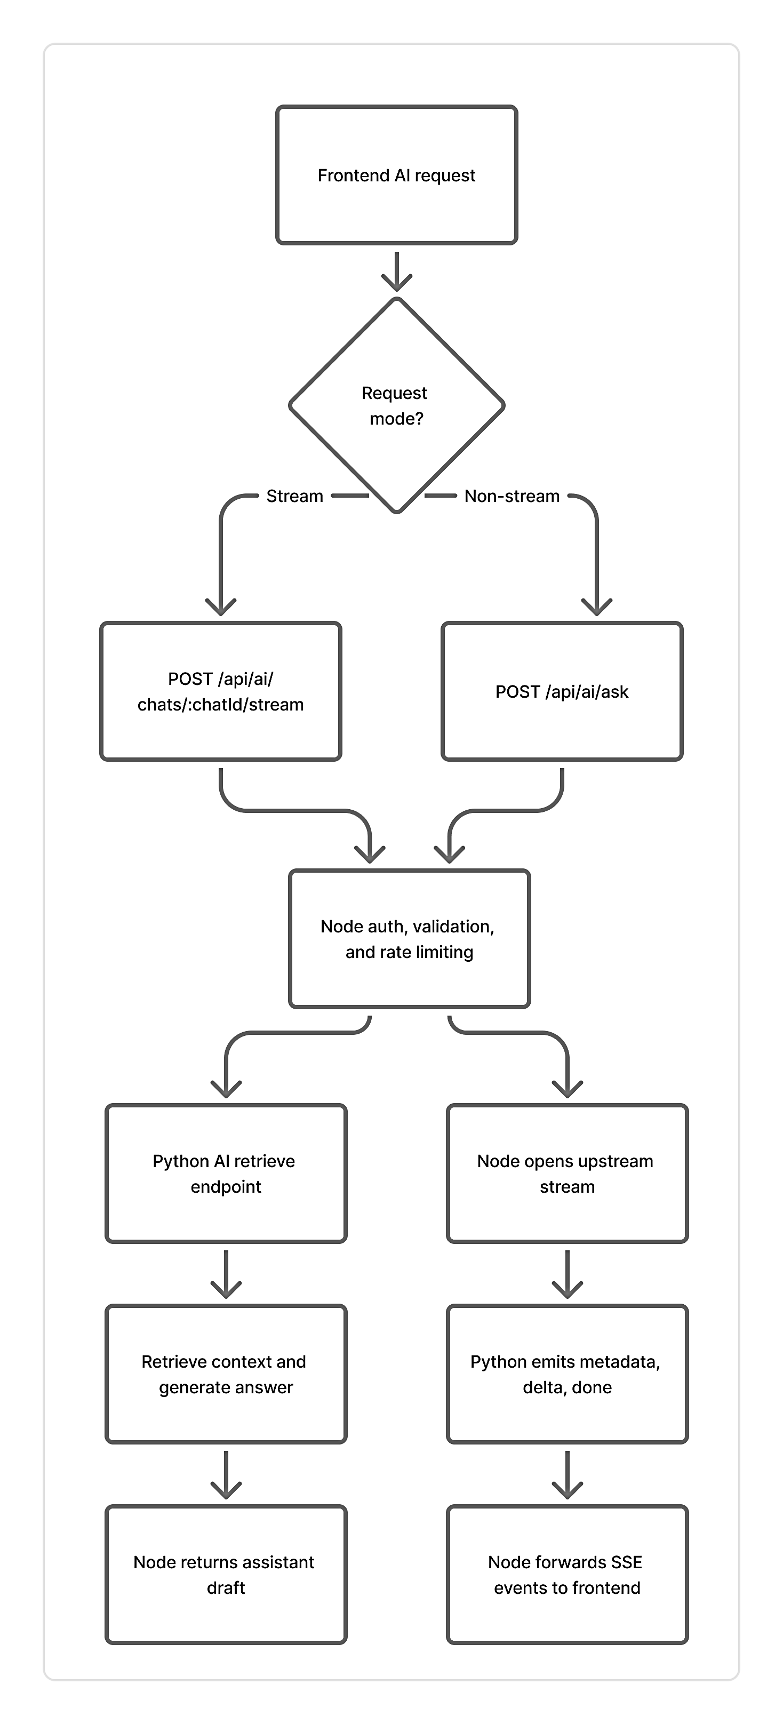
Figure 9.3: RAG Retrieval and Streaming Pipeline for AI Question-Answer Flow

CHAPTER 10

TESTING, EVALUATION, AND DISCUSSION

Unit Testing and Integration Testing

Testing is an important part of this project because the application combines multiple layers: frontend interaction, Node API logic, Python analytics, prediction workflows, and AI-based retrieval. In such a system, correctness cannot be checked only by visual output. It is necessary to test smaller modules independently and also verify whether the major workflows work together correctly.
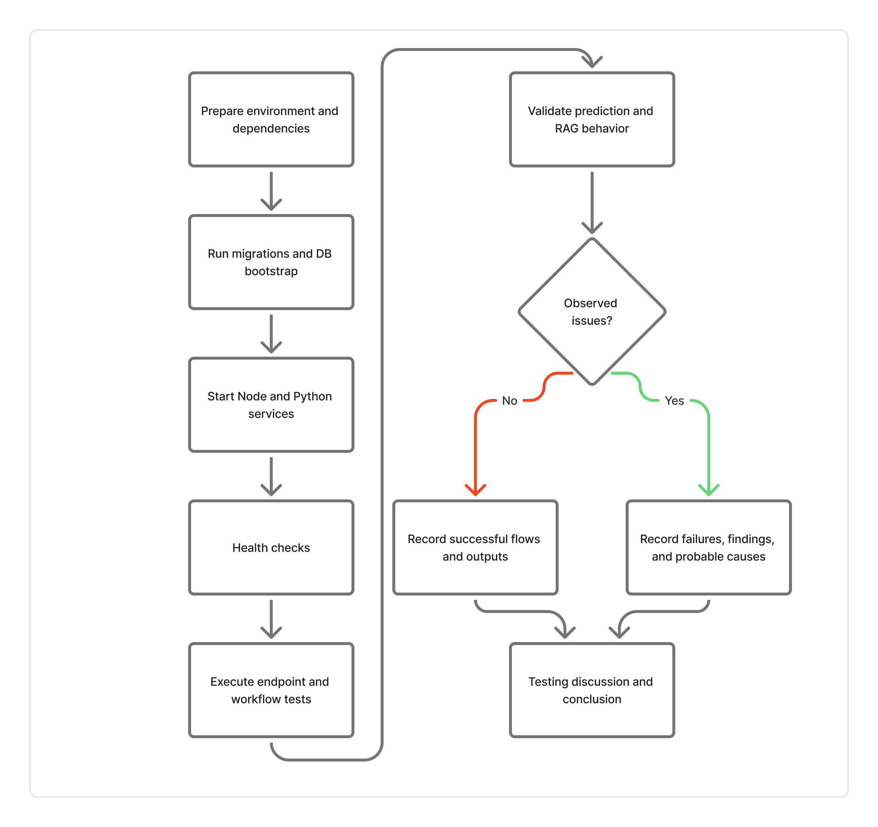
Figure 10.1: Evaluation Flow Followed in Testing and Discussion

The project includes both unit-level and integration-level testing. Unit tests focus on the behavior of individual services or helper functions. Integration tests focus on whether different layers of the application connect properly, especially in the backend flow.
The Python backend contains a broad set of tests for prediction, physics logic, inference, feature engineering, RAG support, schema handling, snapshot behavior, AI retrieval routing, and training-related utilities. This gives good coverage for the analytical side of the system. The Node backend also includes integration-style checks that verify the presence of critical route guards and controller hooks.
From a final-year project perspective, this is a strong testing setup because it does not test only surface-level functionality. It checks both numerical logic and workflow structure. That makes the project easier to trust and easier to improve later.

Prediction Validation

Prediction validation in this project focuses on reliability, shape correctness, and deterministic behavior rather than on one single accuracy metric alone. This is a sensible approach because the project combines formula-based logic with hybrid inference, and the objective is to ensure stable and meaningful behavior under realistic inputs.
The prediction tests verify that:
- generated ideal and actual chart lines have the expected length,
- the same seed produces the same output under the same input conditions,
- different user trends lead to meaningfully different prediction outputs,
- metadata such as seed and calibration information are preserved correctly.

Validation Goal | Why It Matters
Correct Chart Length | Ensures progress outputs are aligned with the  requested horizon
Deterministic Output for  Fixed Seed | Supports reproducibility and debugging
Sensitivity to User Trend  Changes | Confirms that predictions react to different user behavior
Metadata Integrity | Preserves traceability of prediction generation logic

Table 10.2: Key prediction validation goals in the project.

AI Retrieval and Response Testing

The AI coach is one of the most complex parts of the project because it depends on retrieval logic, profile context, user history, and final response generation. For this reason, the project includes tests that focus specifically on RAG behavior and assistant output quality.
These tests cover areas such as deterministic embeddings, fallback retrieval behavior,
intent-sensitive assistant drafting, output validation, and the use of user metrics when the
question requires them. This is especially important because an AI module can appear to work well in casual usage while still producing weak or poorly grounded responses in edge cases.
The tests also verify fallback behavior when real embeddings are not available or when provider-level operations fail. This matters in production-style systems because AI support should degrade gracefully instead of breaking entirely. The project design handles this through deterministic fallback retrieval and validation checks around output completeness.
Another useful testing aspect is response quality validation. The assistant is checked for conditions such as minimum completeness and sentence termination. While these are simple checks, they improve professionalism and prevent obviously poor responses from being treated as acceptable.

Concern | Test Purpose
Deterministic Embedding Stability | Ensure repeated embedding calls remain consistent for  the same input
Fallback Retrieval Behavior | Confirm the system still works when real embedding  mode is unavailable
Intent-aware Assistant  Behavior | Ensure user-data questions trigger context-aware  drafting
Output Validation | Reject incomplete or low-quality generated  responses
Route Orchestration  Correctness | Verify that AI retrieval endpoints trigger the  expected workflow

Table 10.3: Representative AI retrieval and assistant testing concerns.

Experimental Observations

The project is not evaluated only through isolated tests. It also includes practical observations based on how the full workflow behaves across data logging, prediction, and AI assistance.
One important observation is that the architecture supports smooth separation between operational and analytical tasks. The Node backend handles user-facing flows cleanly,
while the Python backend remains focused on data-intensive and AI-intensive logic. This makes the project easier to debug and extend.
Another observation is that the hybrid prediction approach is more practical than using either formulas alone or models alone. Formula-based baseline logic keeps the system understandable, while residual modeling allows the system to react to actual user trends more realistically. This balance improves the usefulness of the generated progress charts.
The AI module also shows a useful pattern: responses become more meaningful when the system has sufficient recent logs. When user-data sufficiency is low, the module can still provide a general answer, but it is naturally less personalized. This is a good sign because it shows that the system is sensitive to context quality rather than pretending to know more than it actually does.
The available end-to-end report in the repository also highlights a realistic engineering lesson: infrastructure or setup issues can break a broader validation harness even when many module-level tests exist. This is valuable to mention because real software systems are affected not only by logic errors but also by integration and environment readiness.

Discussion of Results

From the testing and evaluation activities, it can be said that the project demonstrates good internal consistency across its major modules. The prediction layer is designed with determinism and traceability in mind. The AI layer includes both retrieval grounding
and fallback handling. The backend routes contain validation and protective checks. Together, these aspects show that the system was implemented as an engineering solution rather than as a collection of disconnected features.
At the same time, the evaluation also reveals the realistic limitations of the current stage. The project already contains many module-level and workflow-level validations, but full environment-dependent harness execution can still fail due to setup or infrastructure-related issues. This is not unusual in multi-service systems, and it high- lights the importance of deployment discipline, test environment stability, and controlled initialization steps.
Overall, the results suggest that the project succeeds well as a final-year engineering system. It integrates personalization, predictive analytics, and AI-assisted support in a structured way. The testing evidence supports the claim that the system is modular, reproducible, and extendable. The next chapter concludes the report by summarizing the work, discussing limitations, and identifying future improvements.

CHAPTER 11

CONCLUSION AND FUTURE ENHANCEMENTS

Conclusion

This project set out to build a health and fitness platform that goes beyond basic calorie tracking or static workout suggestions. The main goal was to create a system that could understand user profile information, support daily logging, estimate calorie intake and calorie burn, predict progress over time, and answer questions through an AI-assisted module. Based on the design and implementation presented in the earlier chapters, that goal has been achieved in a meaningful and structured way.
One of the strongest outcomes of the project is that it brings multiple important features into a single connected workflow. The user is not forced to use one application for logging, another for prediction, and another for guidance. Instead, profile setup, plan selection, daily check-ins, progress tracking, and AI-based support are all connected through the same platform. This makes the system more practical and also gives the report a stronger engineering foundation, because each module contributes to a larger end-to-end flow.
Another important contribution of the project is the architectural separation between operational logic and analytical logic. The Node.js backend handles authentication, user-facing routes, plan flows, dashboard aggregation, and request coordination, while the Python service handles calorie analytics, prediction logic, progress summaries, alternative plans, and AI retrieval orchestration. This separation keeps the design maintainable and mirrors the different strengths of the two technology stacks.
The project also demonstrates that personalization becomes more useful when it is grounded in actual user behavior. The progress module does not only show stored values; it interprets how current behavior compares with the expected path. The AI coach does not answer only from generic text generation; it builds its response using profile information, recent logs, and knowledge documents. These aspects make the system more credible and much more relevant than a generic fitness dashboard.
From an academic and implementation point of view, the completed work can therefore be seen as a successful final-year project. It combines full-stack development, data modeling, analytical logic, prediction design, retrieval-based AI support, and testing in one system. The final product is not just a visual prototype. It is a working multi-service application with a realistic architecture and clear scope for extension.

Limitations

Even though the system performs well within the defined scope, it also has a number of practical limitations that should be stated clearly.
The first limitation is that the platform is still a software guidance system, not a clinical medical system. It can estimate trends, suggest plans, and provide useful summaries, but it should not be treated as a replacement for a doctor, certified dietitian, or professional fitness trainer. The recommendations are helpful for guidance and monitoring, but they are not medical prescriptions.
The second limitation is that progress prediction still depends strongly on the quality of user-entered data. If the user skips check-ins, enters inaccurate calorie values, or fails to log workouts correctly, then the resulting progress interpretation will naturally become less reliable. In other words, the quality of personalization depends on the quality of the available data.
Another limitation is that the AI coach is retrieval-grounded but still bounded by the knowledge and logs available to it. If recent user data is missing or if the question goes beyond the stored knowledge base, the assistant may respond in a more general way instead of a deeply personalized way. This is better than hallucinating unsupported details, but it still limits how precise the guidance can be in some cases.
The project also inherits the normal deployment complexity of a multi-service application. Since the frontend, Node backend, Python backend, PostgreSQL database, and optional Redis cache all work together, setup and environment consistency become important. As seen in testing and validation discussions, some broader workflows can fail when infrastructure or initialization is not handled correctly, even if the code logic itself is sound.
Finally, the current system is limited in personalization depth when compared with large- scale commercial health platforms. It does not yet include wearable-device integration, live sensor streaming, long-term adaptive coaching based on months of behavior, or advanced clinical screening logic. These areas remain open for future improvement.

Future Scope

The current project already provides a strong base, but it also opens several useful directions for future work.
One natural extension is deeper personalization. The system can be improved to learn more dynamically from long-term user behavior and not only from short-term recent logs. For example, future versions could adapt plans based on repeated adherence patterns, missed workouts, sleep irregularity, or sustained deviation trends. This would make the recommendation engine more proactive.
Another useful enhancement is wearable and device integration. If the platform can connect to smartwatches, fitness bands, or phone health APIs, it could capture steps, heart rate, workout duration, and sleep data automatically. This would reduce manual entry effort and improve the reliability of the data used by the prediction engine.
The AI coach can also be extended further. At present, it combines retrieval from profile data, recent logs, and knowledge documents. In future versions, it could support memory of longer-term user milestones, better conversational continuity, richer explanation formats, and possibly personalized weekly coaching summaries generated automatically from progress trends.
From the system side, future work could also improve deployment maturity. Containerized orchestration, stronger environment validation, CI-based service integration checks, and production-grade monitoring would make the platform easier to run and maintain beyond an academic setting.
There is also room for richer plan intelligence. The current project already supports alternative plans, but future versions could include finer plan ranking, condition-aware suggestions, vegetarian and non-vegetarian substitution logic at a more detailed level, and adaptive calorie cycling strategies based on recent user adherence and goal progress.
Overall, the project forms a solid foundation for future development. What has been built here is enough to demonstrate a meaningful, practical, and technically coherent health recommendation platform. With more data, stronger integration, and extended analytics, the same system can grow into a much more advanced personalized digital fitness assistant.

CHAPTER A

APPENDICES

Sample API Payloads

This appendix provides short representative payload examples used across the application. These are included to show the kind of structured data exchanged between the frontend, Node backend, and Python analytics service.

Field | Example Value
name | "Jake"
age | 21
sex | "male"
height (cm) | 172
weight (kg) | 78.5
goal type | "weight loss"
diet type | "veg"
activity level | "moderate"

Table A.1: Representative Profile Update Payload

Field | Example Value
date | "2026-03-20"
weight (kg) | 77.9
sleep hours | 7.5
water (liters) | 2.8
calorie consumed (kcal) | 1920
calorie burned (kcal) | 430
steps | 9450
workout completion (%) | 85

Table A.2: Representative Daily Check-in Payload

REFERENCE

- M. D. Mifflin, S. T. St Jeor, L. A. Hill, B. J. Scott, S. A. Daugherty and Y. O. Koh, “A New Predictive Equation for Resting Energy Expenditure in Healthy Individuals,” The American Journal of Clinical Nutrition, vol. 51, no. 2, pp. 241–247, 1990.
- K. D. Hall et al., “Quantification of the Effect of Energy Imbalance on Bodyweight,”
The Lancet, vol. 378, no. 9793, pp. 826–837, 2011.

- P. Lewis, E. Perez, A. Piktus et al., “Retrieval-Augmented Generation for Knowledge- Intensive NLP Tasks,” Advances in Neural Information Processing Systems, vol. 33,
pp. 9459–9474, 2020.

- PostgreSQL Global Development Group, PostgreSQL Documentation. PostgreSQL technical documentation used as a reference for relational database design and database operations in the project.
- Prisma, Prisma ORM Documentation. Reference used for schema design, migration handling, and database access from the Node.js backend.
- FastAPI, FastAPI Documentation. Reference used for the design of analytics routes, request models, and service integration in the Python backend.
- React, React Documentation. Reference used for the frontend component structure, routing flow, and state-driven user interface design.
- Express.js, Express Documentation. Reference used for route organization, middleware flow, and API handling in the Node.js backend.
- Project Documentation, “Architecture, Data Flow, and Database Design Notes,” internal project documents covering system architecture, data flow, and database design.
- Project Documentation, “Dataset, Prediction, and RAG Design Notes,” internal project documents covering dataset schema, prediction workflow, and retrieval-augmented gen- eration design.
- Project Documentation, “API Contracts and Implementation Notes,” internal project reference material covering API contracts and supporting implementation notes.
- Node Backend Source Code, modules under the Node backend source directory, used as the primary reference for authentication flow, profile handling, plan operations, dashboard bootstrap flow, caching, and API orchestration.
- Python Backend Source Code, modules under the Python backend application directory, used as the primary reference for analytics, prediction, recommendation, and AI retrieval workflows.
- Frontend Source Code, modules under the frontend source directory, used as the primary reference for dashboard interaction, tracker interface, daily logging flow, and AI coach integration.
- Testing and Validation Materials, project test files and validation notes, used to support the testing and evaluation discussion in the report.
- Plan and Knowledge Source Documents, internal plan descriptions and knowledge notes, used as the content base for plan structure and AI retrieval support.

